
February 14, 2011
For immediate release
Contact: John Weispfenning
714-628-5030
Weispfenning_John@sccollege.edu

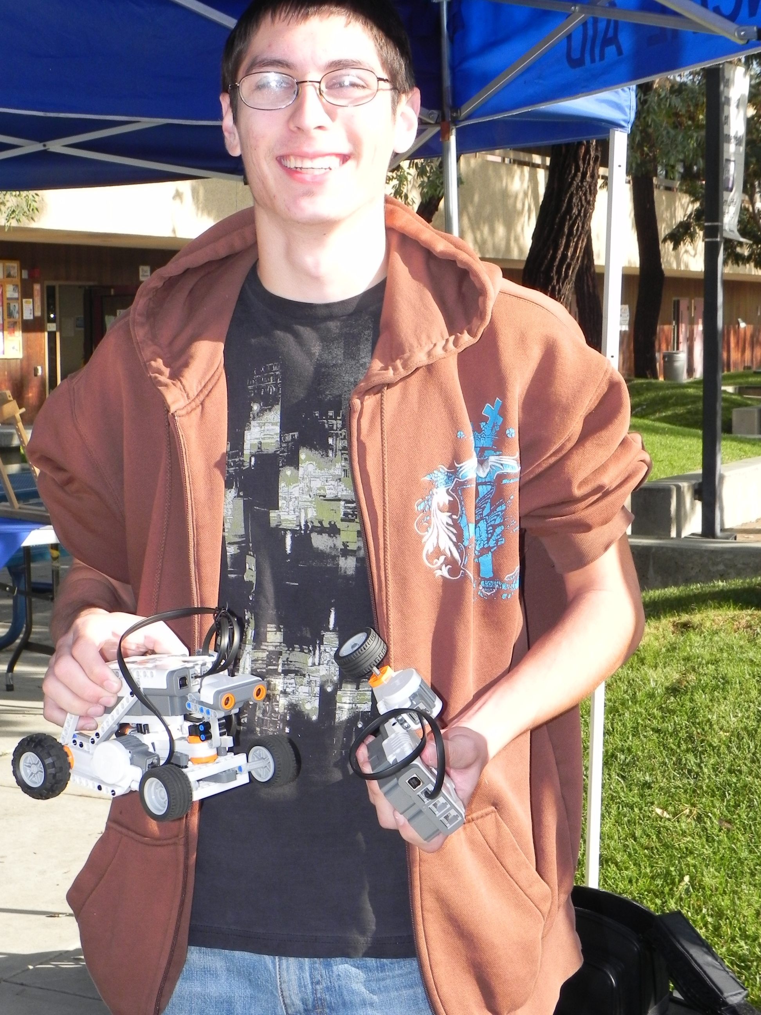

SCC student Hayden Donze with two of the college’s robots.

SCC Robotics Team Advances

Orange—A student team from Santiago Canyon College has advanced to the second round of the international Imagine Cup Programming Challenge, sponsored by Microsoft. More than 450 teams from around the world entered the competition, but only 150 advanced. Of the 13 US entries, only five were selected to move forward.
The SCC students on the team, Syntax Errors, are Gary Kelley Jr. of Santa Ana, Hayden Donze of Orange, Dale Laizure of Anaheim, and Bill Vetter of Orange. They will now compete against the other four US teams including the UCI Engineering Embedded team. In the second round, each team builds a prototype and creates a marketing video. If selected to continue, Microsoft will send the entire team to New York in July to compete in the finals.
-more-
Robotics Team
Page 2

The students’ proposal would enhance communication and logistics in disaster relief efforts with technology to allow rescue personnel easy access to the location of vital resources.
The team formed last semester when four outstanding students in Professor Ron Kessler’s first robotics course in Santiago Canyon’s Computer Science program decided to enter the embedded programming challenge, one of the three separate competitions that make up the Imagine Cup. Embedded programming is used with software for microcontrollers found in cars, traffic signals, communications equipment, and even newer refrigerators and washing machines.
SCC is offering a new 15-unit certificate in Applied Robotics and Embedded Programming to help students gain entry-level positions in engineering and development companies. Kessler said the certificate will prepare students to work with senior engineers as they develop products for tomorrow.
Santiago Canyon College is a public community college of Rancho Santiago Community College District, serving the residents of Anaheim Hills, Orange, Tustin and Villa Park. The college provides education for academic transfer and careers, courses for personal and professional development, and customized training for business and industry.
# # #

