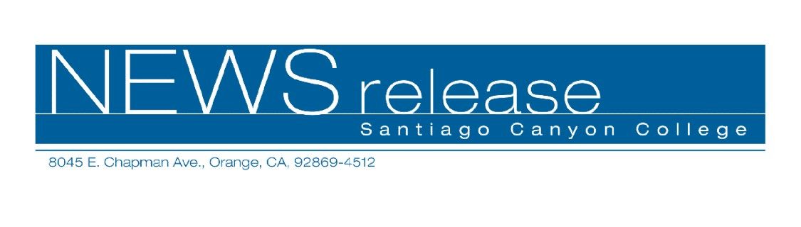
April 6, 2010
For immediate release
Contact: John Weispfenning
714-628-5030
Weispfenning_John@sccollege.edu
Students Display Art at Santiago Canyon College

Orange—Santiago Canyon College (SCC) art students will show their best work in the college’s second annual student art show, May 6-20.
The juried show will begin with a reception from 6:30 to 8 p.m. on Thursday, May 6, in the college library. Art will be on display in the library and in the D-building.
Live guitar music will be performed at the reception, which is free and open to the public.
“All the participants have been selected by their instructors, and their work exemplifies the best art produced at the college,” said Moira Hahn, chair of the SCC Art Department. “The show is a testament to the impressive artistic talent and creative ability of SCC students, and they are delighted to have an opportunity to display their excellent work for the community to enjoy.”
Works created by students during the current academic year will be featured, including drawings, life drawings, traditional and experimental paintings, stained glass, fused glass, slumped glass, two-dimensional designs, three-dimensional designs, and digital art works.
“Most of the artwork is available for purchase, and the art is affordably priced,” Hahn said. The show is supported by donations from Art Supply Warehouse, Aaron Brothers, and Lyon Art Supply.
The show will continue from 9 a.m. to 7 p.m., Monday through Thursday until May 20.
Santiago Canyon College is a public community college of Rancho Santiago Community College District, serving the residents of Anaheim Hills, Orange, Tustin and Villa Park. The college provides education for academic transfer and careers, courses for personal and professional development, and customized training for business and industry.

# # #

