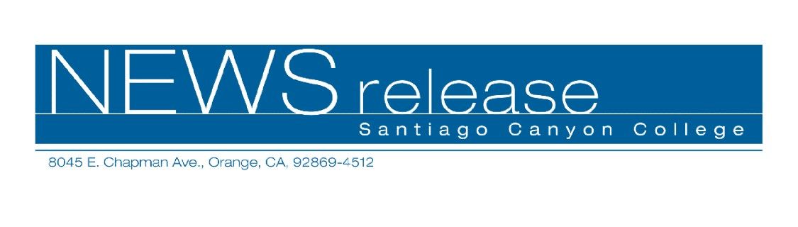
May 19, 2010
For immediate release
Contact: John Weispfenning
714-628-5030
Weispfenning_John@sccollege.edu
Santiago Canyon College Golfer Wins State Title

Orange—A sophomore at Santiago Canyon College won the state community college individual golf championship, May 17, in Beaumont, Calif.
Connor Covington posted a 4-under-par score of 140 for two rounds (70-70) on the 72-par, 6,937 yard course at Oak Valley Golf Club to win the 2010 California Community College Athletic Association’s men’s title. Covington won a card-off to earn medalist honors over Palomar College’s Sejun Yoon, who also had two rounds of 70.
Covington’s score also earned him All-State honors.
This is the first golf championship for Santiago Canyon College in the school’s ten year history.
Covington was an underdog in the state tournament. He was the final individual from Southern California to make the field, finishing in a four-way tie for 12th place at last week’s regional finals. There, too, he won a card-off, which qualified him for the championship berth.
Covington is a two-time All-Conference Orange Empire Conference (OEC) selection, and he earned medalist honors at this season’s OEC finals.
Covington is a graduate of Villa Park High School.
Santiago Canyon College is a public community college of Rancho Santiago Community College District, serving the residents of Anaheim Hills, Orange, Tustin and Villa Park. The college provides education for academic transfer and careers, courses for personal and professional development, and customized training for business and industry.

# # #

