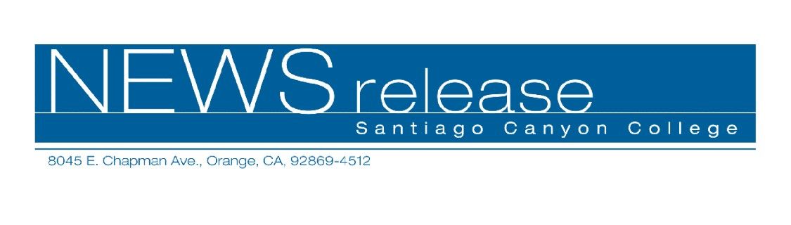
August 20, 2009
For immediate release
Contact: John Weispfenning
714-628-5030
Weispfenning_John@sccollege.edu
SCC Student Wins Painting Awards at OC Fair

Orange— A Santiago Canyon College (SCC) art student won three major awards for her painting at the 2009 Orange County Fair.
Candy Frost, of La Habra, won Best of Show, Best of Division-Amateur Painting, and First Place in Amateur Painting-acrylics for her mixed-media self-portrait. The work began with newsprint featuring Chinese-language symbols, the painted self-portrait, and included printed wrapping paper.
“I asked myself, ‘What would it be like if someone had no one to keep them company, only an image?’” Frost said. “That’s what I thought as I painted.”
Frost has been taking art classes at SCC for several years, and she counts Department of Art Chair Moira Hahn as a major influence on her work. “Moira has provided me with encouragement,” Frost said. “Moira is the best. She has helped me to keep open-minded to ideas no matter where they come from.”
Frost and her husband, Frank, own a home in Mexico and she is completing a mural at a restaurant in La Bufadora, 16 miles south of Ensenada. The mural includes a seven-foot long painting of a mermaid, based on a girl who had acted with a local theater group. “She had never posed before,” Frost said. “Once I finished the drawing, she got excited to see the finished painting.”
The painting is above a doorway and has two sides showing the front and back of the mermaid. “The rooms have mirrors, so you can see the front and back at the same time,” Frost said.
-more-

2-2-2

Using her art to benefit others is important to Frost. A mermaid print she produced for an SCC class was later a big draw at a charity auction to benefit children in Mexico. “My art has helped others, and that’s the best thing about it.”
Santiago Canyon College is a public community college of Rancho Santiago Community College District, serving the residents of Anaheim Hills, Orange, Tustin and Villa Park. The college provides education for academic transfer and careers, courses for personal and professional development, and customized training for business and industry.

# # #

