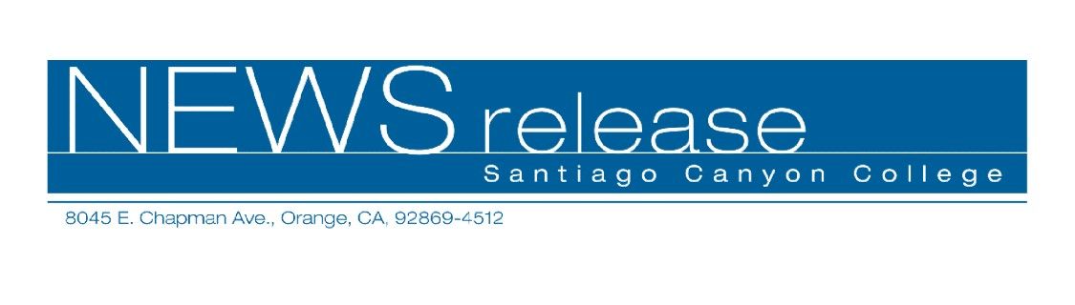
September 27, 2010
For immediate release
Contact: John Weispfenning
714-628-5030
Weispfenning_John@sccollege.edu
SCC Celebrates Hispanic Heritage Month
With Latin American Film Festival

Orange— Santiago Canyon College will present three films in October as part of its annual Latin American Film Festival. The films are open to the public and are presented by the Languages Department as part of Hispanic Heritage Month.
The festival begins with Lista de Espera/The Waiting List on Friday, October 15. This 2000 allegorical romantic comedy/drama from Cuba features a disparate group of people waiting for the bus at a rundown transit station. From award-winning director Juan Carlos Tabío, this blend of magical realism and social commentary has been nominated for Best Film awards at festivals in Spain and in Latin America.
The second film in the festival is Los Viajes Del Viento/The Wind Journeys on Friday, October 22. This 2009 award-winning drama from Colombia features an old accordion-playing troubadour who embarks on a last journey with a young apprentice. Together they travel discovering the musical diversity of Caribbean culture. Los Viajes Del Viento has won awards for Best Film at the Santa Barbara International Film Festival, the Cannes Film Festival, and at festivals in Colombia.
The final film in the festival is No Te Mueras Sin Decirme Adonde Vas/Don’t Die Without Telling Me Where You’re Going on Friday, October 29. This 1995 romantic drama from Argentina from director Eliseo Subiela delivers a touching time-shifting story about the enduring power of love. Adapted from a novel by Uruguayan writer Hermenegildo Sábat, the film has won awards at festivals in Switzerland, Canada, and Spain.
All three films begin at 6 p.m. in Room D-101, and will feature an introduction and short discussion by the Languages Department faculty. The films are in Spanish with English
-more-
Latin American Film Festival
2-2-2
subtitles, and have not been rated by the MPAA. Admission and parking are free. For more information, call (714) 628-4938 or (714) 628-4742.
Santiago Canyon College is a public community college of Rancho Santiago Community College District, serving the residents of Anaheim Hills, Orange, Tustin and Villa Park. The college provides education for academic transfer and careers, courses for personal and professional development, and customized training for business and industry.
# # #

