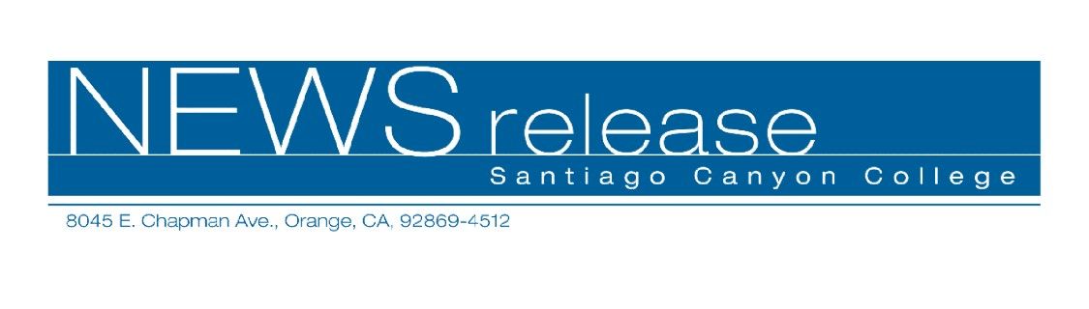
October 8, 2009
For immediate release
Contact: John Weispfenning
714-628-5030
Weispfenning_John@sccollege.edu
SCC Latin American Film Festival
Celebrates Hispanic Heritage Month

Orange— Santiago Canyon College will present three films in October as part of its annual Latin American Film Festival. The films are open to the public and are presented by the Languages Department as part of Hispanic Heritage Month.
The festival begins with Casi Divas/On the Road to Fame on Friday, Oct. 16. This 2008 comedy features four ambitious, young women from across Mexico caught up in a nationwide talent search.
The second film in the festival is Viva Cuba on Friday, Oct. 23. This award-winning light drama from Cuba examines the friendship between two children threatened by their families’ class differences. Viva Cuba won the Grand Prize in Children’s Cinema at the 2005 Cannes Film Festival.
The final film in the festival is Sleep Dealer/Traficante De Sueños on Friday, Oct. 30. An award-winning science fiction film from 2008, Sleep Dealer highlights provocative issues such as migrant labor in the global economy.
All three films begin at 6 p.m. in Room D-101, and will feature an introduction and short discussion by the Languages Department faculty. The films are in Spanish with English subtitles. Admission and parking are free. For more information, call 714-628-4938 or 714-628-4742.
Santiago Canyon College is a public community college of Rancho Santiago Community College District, serving the residents of Anaheim Hills, Orange, Tustin and Villa Park. The college provides education for academic transfer and careers, courses for personal and professional development, and customized training for business and industry.
# # #

