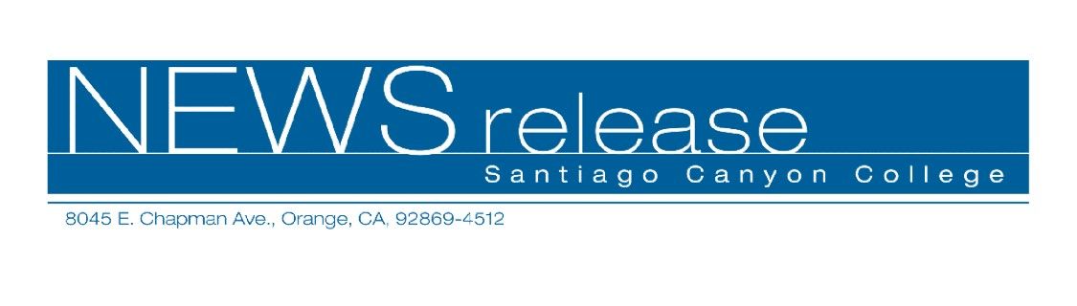
November 19, 2010
For immediate release
Contact: John Weispfenning
714-628-5030
Weispfenning_John@sccollege.edu
Faculty Award Recipient to Discuss Arts in Crisis

Orange—The survival of the arts during times of crisis will be discussed by Larry Ball, professor of music and the 2010 Santiago Canyon College Faculty Excellence recipient, December 2.
Known to his students and colleagues as “DB” (short for “Dr. Ball”), he is the founding faculty member in music at the SCC campus, beginning when it was the Orange Campus of Rancho Santiago Community College District (RSCCD) in 1985.
The presentation will begin by exploring how music survived in difficult times in the early 20th Century, which will be followed by performances by a five-piece Pacific Harp Ensemble and the Pacific Chamber Ensemble with students.
The presentation is at 1 p.m., Thursday, December 2, in the Santiago Canyon College Science Center, room 105. The presentation is free, but seating is limited.
The Faculty Excellence Award is the highest honor bestowed by colleagues upon a faculty member of Santiago Canyon College. Nomination criteria include service to the college, commitment to student success, curriculum development, and academic leadership. Students and faculty nominate candidates, and final selection is determined by faculty vote.
With 35 years of service to the district, Ball teaches music appreciation and has taught voice and choral conducting, and has led the Chamber Choir and the California Master Chorale and Orchestra.
Ball has served on numerous college committees, and he has developed bridge and transfer programs to encourage talented students to enroll in SCC’s choral and voice classes. He is past national president of the board of directors of the Choristers Guild and the National
-more-
Santiago Canyon College
Faculty Excellence Lecture
Page 2

Association of Church Musicians. He holds a doctorate in music education from the University of Southern California and bachelor’s and master’s degrees from Milliken University.
Ball was the founder and conductor of the California Master Chorale and orchestra from 1975-2004. From 1966-1998, he was minister of Worship and Music at First Presbyterian Church in Orange. He also served as minister of music and principal conductor at the Crystal Cathedral. There he conducted the Cathedral Choir for the Hour of Power international telecast and oversaw a large music staff. In 2005, Ball retired as minister of music and worship from St. Andrew’s Presbyterian Church in Newport Beach after completing more than 45 years in full time church music. At his retirement, the Session of St. Andrew’s conferred the title of emeritus to honor his many years of distinguished musical leadership and service locally and nationally.
In addition to conducting symphony orchestras and choirs, Ball continues a passion for researching and discovering choral literature throughout the world. Many of his research finds have been premiered involving SCC students over the past 20 years. In 1998, Ball conducted the rediscovered Benjamin Britten masterpiece, The World of the Spirit (1938) in a west coast premiere and again at Carnegie Hall in New York.
Santiago Canyon College is a public community college of Rancho Santiago Community College District, serving the residents of Anaheim Hills, Orange, Tustin and Villa Park. The college provides education for academic transfer and careers, courses for personal and professional development, and customized training for business and industry.

# # #

