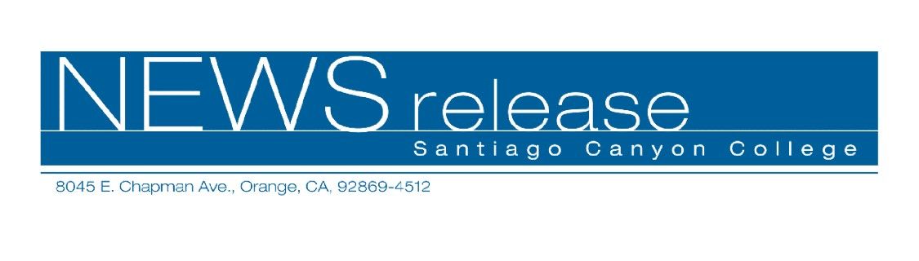
FOR RELEASE: IMMEDIATELY
CONTACT: ANNMARIE LIBRESCU
714-628-4745
librescu_annmarie@sccollege.edu

Start Your Notary Public Career in November
November 2—Did you know that notaries can earn hundreds of dollars a day signing documents for legal and professional industries? Enter this lucrative field and start your own full- or part-time business this month! Santiago Canyon College’s Community Services program offers two classes in November to help you get started. “Become a Notary in One Day!” will be held on Saturday, November 5 and the companion class “How to Start a Notary Signing Business” is on Saturday, November 19.
The intensive “Become a Notary in One Day!” workshop covers everything about becoming a reliable and effective notary. Learn about new legislation, how to pass the test, fill out certificates and journal entries, identify document signers and avoid lawsuits.
Students who successfully complete the six-hour (8:00 a.m. to 4:00 p.m.) workshop on November 5 may take the State of California Public Notary exam that will be given immediately afterward. You must be at least 18 years old, have a valid photo ID and be a legal California resident (military excluded). To become a notary, you must pass the state exam and a background check.
The cost is $85 plus a $20 material fee payable in class. To take the state exam, you will need a $40 check payable to the Secretary of State.
Once you’ve become a notary, begin your career quickly with“How to Start a Notary Signing Business.” The workshop will be held on November 19 from 9:00 a.m. to 4:00 p.m. You’ll discover how to build and maintain your signing business by making profitable contacts and signing with services agencies. You’ll learn how to notarize loan packages, negotiate fees, advertise for business and develop your own clientele in five easy steps.

The cost for “How to Start a Notary Signing Business” is $89 plus a material fee of $30 payable at the door. An optional certificate of completion is available for $20.
Both notary classes are taught by Notary Public Seminars, Inc., a leading public course provider in California for over 10 years. Classes are held at Santiago Canyon College, building D, room 216. The college is located at 8045 E. Chapman Avenue in Orange.
Pre-registration is required and space is limited. For more information or to register, call (714) 628-4960 or visit www.sccollege.edu/cs.
Santiago Canyon College is a public community college of Rancho Santiago Community College District serving the residents of Anaheim Hills, Irvine, Orange, Tustin and Villa Park. The college provides education for academic transfer and careers, courses for personal and professional development, and customized training for business and industry.

###

