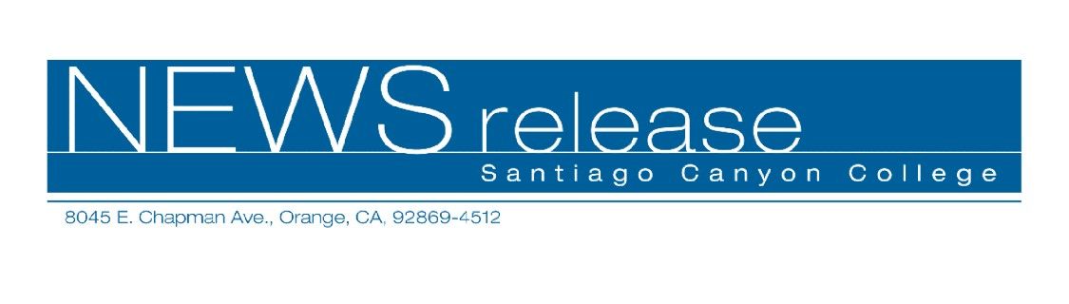
FOR RELEASE: IMMEDIATELY
CONTACT: ANNMARIE LIBRESCU
714-628-4745
librescu_annmarie@sccollege.edu
Day of the Dead (Dia de los Muertos) Observance at Santiago Canyon College

October 25—The public is invited to join Santiago Canyon College’s Day of the Dead/Dia de los Muertos festivities on Wednesday, November 2, from 10:00 a.m. to 2:00 p.m. in the A/B quad. The celebration will feature music, cultural displays including four colorful, decorated altars and traditional Mexican food (tamales, pan de muerto or “bread of the dead” and jamaica, a beverage). This free event is hosted by SCC’s Spanish Club, Associated Student Body and Spanish honors classes.
The Day of the Dead/Dia de los Muertos is an ancient tradition in Mexican and some Central American cultures. Today it is celebrated as a festive holiday to remember loved ones who have died and commemorate the endless cycle of life and death that is human existence. Families may visit and decorate gravesites, set up altars at home in honor of deceased relatives, and prepare traditional special foods and candy (such as sugar skulls and pan de muerto.)

The college is located at 8045 E. Chapman Avenue in Orange, at the corner of Chapman and Newport Boulevard. Free parking is available in lots 1 and 2. For more information about the Day of the Dead/Dia de los Muertos celebration please contact Lourdes Fajardo at (714) 628-4938. For a map or directions to the college visit the website at http://www.sccollege.edu.
Santiago Canyon College is a public community college of Rancho Santiago Community College District, serving the residents of Anaheim Hills, Irvine, Orange, Tustin and Villa Park. The college provides education for academic transfer and careers, courses for personal and professional development, and customized training for business and industry.

###

