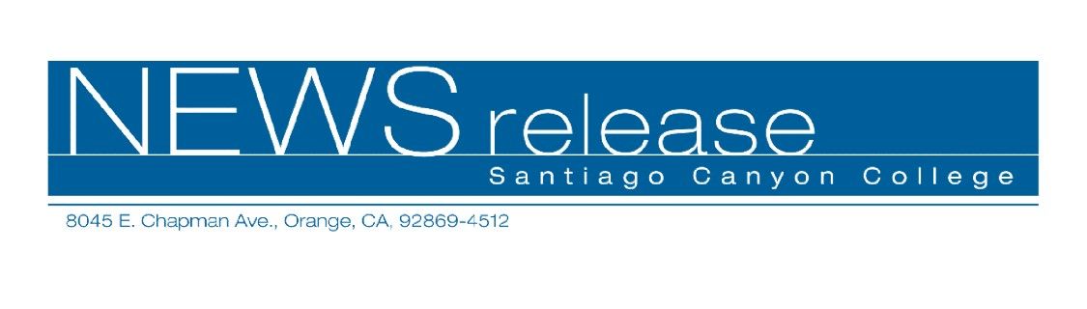
FOR RELEASE: IMMEDIATELY
CONTACT: ANNMARIE LIBRESCU
714-628-4745
librescu_annmarie@sccollege.edu

“The Vagina Monologues” Presented by Santiago Canyon College to Benefit Women’s Charities

March 23 – A one-time benefit performance of the renowned off-Broadway production, “The Vagina Monologues” by Eve Ensler, will be performed on Sunday, April 15, 7:00 p.m. at Santa Ana College’s (SAC) Phillips Hall Theater, located at 1530 West 17th Street in Santa Ana. The performance will benefit local charities, Su Casa Domestic Abuse Network and MADRE in support of V-Day 2007, a global movement to end violence against women.
“This production isn’t about a part of the human anatomy,” said Narges Niedzwiecki, production director, narrator and assistant professor of history at Santiago Canyon College. “Instead, it helps people understand women’s issues and experiences. This benefit performance will raise money for a very worthy cause, ending violence toward women and girls. We hope you’ll join us.”
The production, staged by Santiago Community College’s (SCC) Amnesty International student organization for the promotion of human rights, will include students and faculty as actors and is sponsored by the SCC and SAC Presidents’ Offices. Tickets are on sale now and are available for purchase at the door for $15 per person. Attendees will also be invited to participate in a silent auction to raise funds.
Free parking in student lots adjacent to the Phillips Hall Theatre can be accessed through the Bristol Street entrance to Santa Ana College. For information or reservations, please contact Narges Niedzwiecki at (714) 628-4940 or niedzwiecki_narges@sccollege.edu.
Santiago Canyon College and Santa Ana College are public community colleges of Rancho Santiago Community College District, serving the residents of Anaheim Hills, East
-more-
Santiago Canyon College Presents “The Vagina Monologues” 2 of 2

Garden Grove, Irvine, Orange, Santa Ana, Tustin and Villa Park. Both colleges provide education for academic transfer and careers, courses for personal and professional development and customized training for business and industry.

About V-Day
V-Day is a global movement to end violence against women and girls. Funds and awareness are raised through benefit productions of playwright/founder Eve Ensler’s award-winning play, “The Vagina Monologues.” In 2006, more than 2,700 V-Day events were held around the world. To date, V-Day has raised over $35 million in the fight to end violence against women.

About Su Casa Domestic Abuse Network and MADRE
Su Casa Domestic Abuse Network is a local nonprofit, community-based organization providing services to victims and survivors of domestic violence. Visit www.sucasadv.org for more information.

MADRE is an international human rights organization that works in partnership with community-based women's groups worldwide. Visit www.madre.org for more information.

# # #

