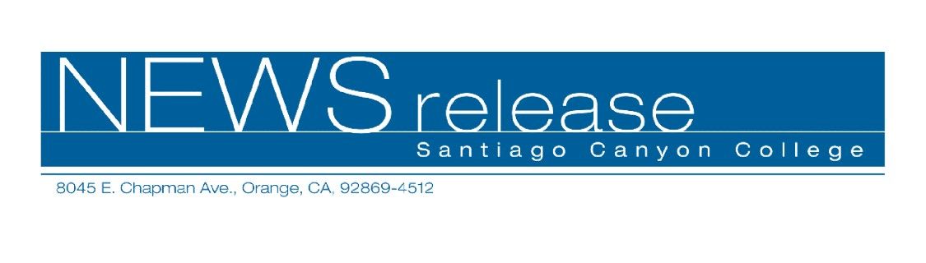
FOR RELEASE: IMMEDIATELY
CONTACT: ANNMARIE LIBRESCU
714-628-4745
librescu_annmarie@sccollege.edu
Santiago Canyon College Holds Ninth Annual Commencement

May 28—Santiago Canyon College (SCC) holds its ninth annual commencement exercises on Friday, June 6, at 5:00 p.m. on campus at Strenger Plaza. There are 728 students who are eligible to graduate, ranging in age from 19-59 years.
This year’s valedictorian is David Charles Donley of Orange. Donley graduates with a 4.0 grade point average and two associate degrees (in history and liberal arts). He is a member of the Honors Program, a President’s Scholar, and has earned highest honors and department honors. He will attend California State University, Fullerton in the fall, where he plans to earn at least one master’s degree. His career goal is to become a teacher at the community college level.
An active student, David was involved in the Teachers for Tomorrow club, the Inter-Club Council and served in various leadership roles in the Philosophical Society. He also worked as a social science tutor in the tutoring center. In April, he received a 2008 Board of Trustees President’s Scholar Award for his achievements.
The salutatorian is 19-year-old Jennifer Faith of Fountain Valley. She graduates with a 3.9 grade point average and is transferring to the University of California at Berkeley this fall where she’ll study psychology. Faith plans to earn her master’s degree and become an occupational therapist.
While a student at SCC, Faith was in the Honors Program and on the championship women’s soccer team for two years. She was selected for the First Team, All Orange Empire Conference in 2007.
This year’s commencement speaker (determined by student vote) is Jared Kubicka-Miller of Long Beach. Kubicka-Miller is an assistant professor of communication and a coach
--more--
Santiago Canyon College Holds Ninth Annual Commencement 2 of 2

for the college’s successful forensics (speech and debate) team. In addition to teaching and traveling with the team and other coaches, he is active in the Speakers Symposium. A member of the Santiago Canyon College faculty since 2006, his areas of expertise include argumentation, debate and group dynamics.
“I congratulate the graduating class of 2008,” said Santiago Canyon College President Juan Vázquez. “On behalf of college faculty, staff and administrators, I wish each and every graduate much success in the future!”
Over 1,200 people are expected to attend the commencement ceremony on June 6. A reception for graduates follows in the A/B Quad.
Santiago Canyon College is a public community college of Rancho Santiago Community College District, serving the residents of Anaheim Hills, Orange and Villa Park. The college provides education for academic transfer and careers, courses for personal and professional development, and customized training for business and industry.

# # #

