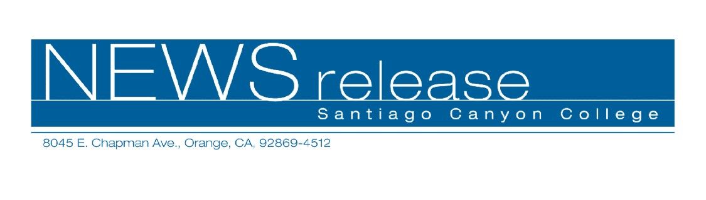
October 31, 2008
FOR RELEASE: IMMEDIATELY
CONTACT: ANNMARIE LIBRESCU
714-628-4745
librescu_annmarie@sccollege.edu
Celebrate TGIF at Santiago Canyon College
Orange—Want to do some holiday shopping that also benefits a good cause? Then plan to attend the Santiago Canyon College Foundation’s annual fundraiser, TGIF, on Friday, November 21, 6:30 p.m. in the beautiful college library. The annual TGIF event (which stands for Treasures, Gratitude, Involvement and Friendship) features a silent auction including many unique items sure to please that “person who has everything” on your holiday gift list. Just a few of this year’s auction items include tickets to see Grease at the Orange County Performing Arts Center in a new production direct from Broadway, tickets to a Disney on Ice performance, and a suite at a Ducks hockey game for you and three of your closest friends. You can shop guilt-free knowing that proceeds benefit student scholarships and support programs. Tickets are on sale now for $50 per person (includes parking, hors d’oeuvres, silent auction, brief program and presentation of the Hawk Spirit of Excellence Award).
“This celebration is an opportunity to gather with friends and acknowledge those who help our students achieve their educational goals,” said Kari Caldwell, director of college advancement. “At the same time, we’re raising funds to provide financial assistance to deserving students. During these tough economic times, scholarships from TGIF proceeds and other donations may make the difference between students staying in school or dropping out.”
This year’s Hawk Spirit of Excellence Award winner is Orange County Coastkeeper, a Newport Beach-based organization dedicated to preserving the county’s coastline and bodies of water and restoring them to healthy, fully functioning systems that will protect recreational uses and aquatic life.

--more--

Celebrate TGIF at Santiago Canyon College 2 of 2

For TGIF tickets or information, please call (714) 628-4790 or visit the web site at www.sccollege.edu/foundation. A portion of the ticket price qualifies as a charitable contribution and may be tax-deductible.

About Santiago Canyon College
Santiago Canyon College is a public community college of Rancho Santiago Community College District serving the residents of Anaheim Hills, Irvine, Orange, Tustin and Villa Park. The college provides education for academic transfer and careers, courses for personal and professional development, and customized training for business and industry.

# # #

