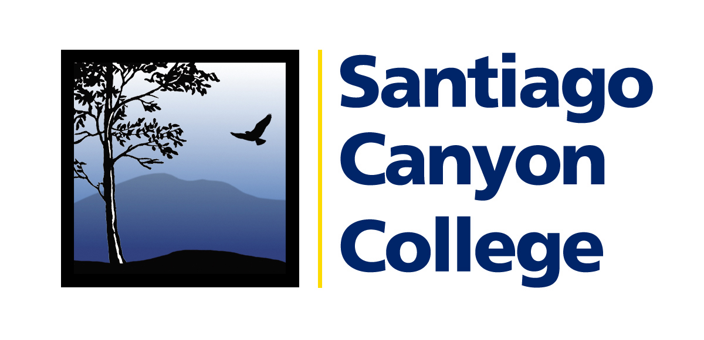

CALENDAR LISTING

Contact: AnnMarie Librescu
Phone: (714) 628-4745
E-mail: Librescu_annmarie@sccollege.edu

Orange County Science Festival Presentations
at Santiago Canyon College

WHAT: As part of the first annual Orange County Science Festival, a collaboration between Santiago Canyon College, the University of California, Irvine and Orange Coast College, each institution will host speakers on various topics during the month of October.

Santiago Canyon College OC Science Festival events are free and open to the public. Offerings include:

Saturday, October 25 at 4:00 p.m., “Dark Matter Satellites of the Milky Way,” astronomy presentation by U.C.I. doctoral student Erik Tollerud. Tollerud has co-authored a paper on the subject and also presented at the U.C. Santa Cruz 2008 Galaxy Formation Workshop.

- Thursday, October 30 at 6:00 p.m., “Bluebird Trails: The Monitoring of Breeding Western Bluebirds in Orange County,” presented by Santiago Canyon College Associate Professor of Biology and Department Co-Chair Michael Taylor.

WHERE: Santiago Canyon College, building D, room 101
8045 E. Chapman Avenue, Orange
Free parking is available in all lots
For a map or directions, visit the web site at www.sccollege.edu

WHEN: Saturday, October 25, 4:00-5:00 p.m., “Dark Matter Satellites of the Milky Way”
Thursday, October 30, 6:00-7:00 p.m., “Bluebird Trails: The Monitoring of Breeding Western Bluebirds in Orange County”

PRICE: FREE

CONTACT: For more information please call 714-628-4771.

# # #

