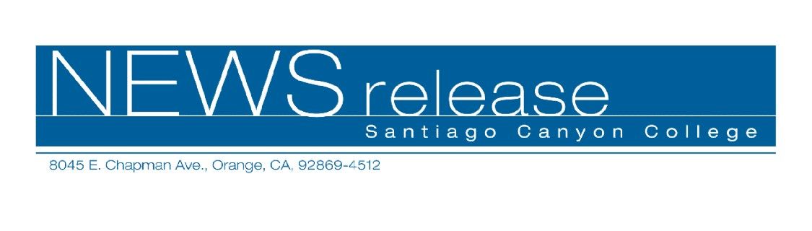
May 19, 2009
FOR RELEASE: IMMEDIATELY
CONTACT: ANNMARIE LIBRESCU
714-628-4745
librescu_annmarie@sccollege.edu

Santiago Canyon College Choirs to Perform at Carnegie Hall
Collegiate Choir and Orange Community Master Chorale invited to New York

Orange—Santiago Canyon College’s (SCC) Collegiate Choir and Orange Community Master Chorale travel to New York on May 20 to perform at one of the world’s most famous concert venues, Carnegie Hall. Under the direction of Michael Short, college director of choral activities, 80 singers from Orange will appear on stage with choirs from Arkansas and Florida. Backed by the New England Symphonic Ensemble, the group will perform Morten Lauridsen’s “Lux Aeterna” and the work of other American composers. The performance is on Saturday, May 23 at 8:00 p.m.
The members of the Orange contingent, along with an entourage of 15 parents and chaperones, left for New York on May 20 and will spend four days in the Big Apple. “Students have been raising money for months to cover the cost of this trip,” Short said. “They’ll have some free time to enjoy New York City before our trip culminates in the Carnegie Hall performance. It will be an amazing experience that the singers will remember for the rest of their lives.”
The invitation to perform was extended by MidAmerica Productions, an independent producer of classical concerts held at Carnegie Hall and other concert venues. Every choir or musical ensemble is specifically recommended or referred, and groups must submit audition tapes before being selected to perform.
Santiago Canyon College is a public community college of Rancho Santiago Community College District, which serves the residents of Anaheim Hills, Orange, Tustin and Villa Park. The college provides education for academic transfer and careers, courses for personal and professional development, and customized training for business and industry.

###

