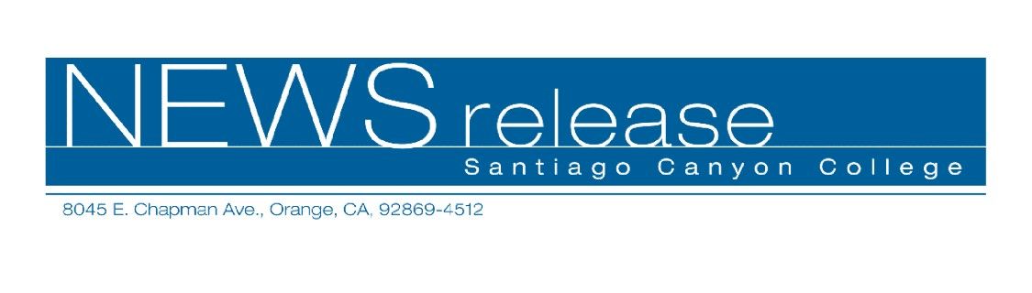
April 14, 2010
For immediate release
Contact: John Weispfenning
714-628-5030
Weispfenning_John@sccollege.edu
SCC Announces Lineup for 2010 International Film Festival
Orange—Santiago Canyon College will present three films in April as part of its annual International Film Festival, sponsored by the Languages Department.
The films are free and open to the public.
The festival begins with Diva on Friday, April 16. This 1981 award-winning film captures the characters, intrigue, romance, and music of the discos of Paris. Intricate and stylish, Diva is in French with English subtitles. Diva is rated R
The second film in the festival is Tea with Mussolini on Friday, April 23. In pre-World War II Florence, dictator Benito Mussolini makes a promise to expatriates who stay in Italy rather than seek refuge in their own countries. This 1999 “dramedy” is directed by Franco Zeffirelli and is rated PG. Tea with Mussolini is in Italian and English with English subtitles.
The final film in the festival is Volver on Friday, April 30. Director Pedro Almodóvar explores the interactions among three generations of women in a Spanish family. Mixing elements of thriller, melodrama and comedy, Volver is full of plot twists and turns. Winner of the Best Screenplay award at the Cannes Film Festival in 2006, Volver is rated R and is in Spanish with English subtitles.
All three films begin at 6 p.m. in Room D-101, and will feature an introduction and short discussion by the Languages Department faculty. Admission and parking are free. For more information, call 714-628-4938 or 714-628-4742.
Santiago Canyon College is a public community college of Rancho Santiago Community College District, serving the residents of Anaheim Hills, Orange, Tustin and Villa Park. The college provides education for academic transfer and careers, courses for personal and professional development, and customized training for business and industry.
# # #

