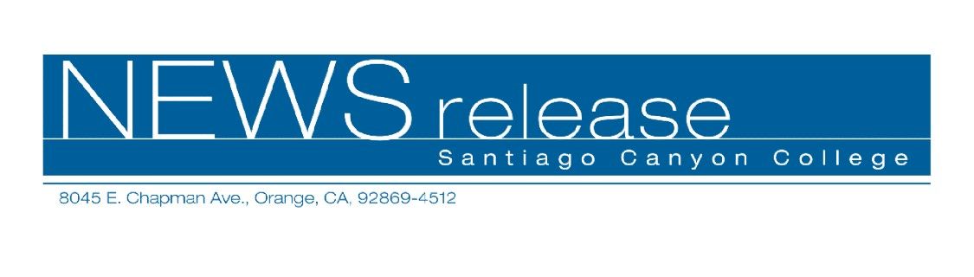
February 28, 2011
Media Alert
Contact: John Weispfenning
714-628-5030
Weispfenning_John@sccollege.edu

Santiago Canyon College Hosts Sixth Annual Community Science Night on March 4

WHAT For the sixth consecutive year, Santiago Canyon College (SCC) has created a night devoted to science. Some 500 families from elementary schools in Orange Unified School District have been invited to a night of hands-on science experimentation and inquiry.
More than 30 different activities have been planned for classrooms campus-wide, including:
- SCC computer science instructor Ron Kessler and his robotics class will display the robots built by SCC students.
- From SCC’s Career Technology Education Department, instructor Gregory Sebourn will put the spotlight on surveying, and instructor Lothar Vallot will dazzle with an introduction to gemology.
- SCC physics instructor Craig Rutan and geology instructor Eric Hovanitz will host, “The Physics of Sound” to allow children and their parents to explore resonance and other aspects of sound.
- SCC biology instructor Denise Foley will provide a close-up look at frog anatomy.
- SCC astronomy instructors Morrie Barembaum, Danny Martino, Mark Maier, Wade Mayo, and Hassi Norlen will set up telescopes to view the night sky and to answer questions about stars and planets.
- SCC anthropology instructor Nick Magalousis will display artifacts.
- SCC instructor Anita Varela and her Elementary Field Experience students will encourage participation in a math game, “What’s My Number?”

WHERE Santiago Canyon College ➔ 8045 E. Chapman, Orange, CA 92869

WHEN Friday, March 4, 2011 ➔ 6:00 p.m. to 8:30 p.m.
WHO This event is not open to the public. Teachers, instructors, and others who volunteer for the event may invite their students, families, and friends.This event is made possible through a generous donation from the Arnold and Mabel Beckman Foundation. In addition, support was provided by Chick-fil-A Restaurant, Inside the Outdoors, Municipal Water District of Orange County, Rainforest Café, Sea and Sage Audubon Society, and Tucker Wildlife Sanctuary.

WHY For many families, Community Science Night is their first time on a college campus. The event reveals the fun and excitement of inquiry-based science and learning. Event co-coordinator and SCC physics instructor Cindy Swift says, “We look forward to this event every year because there is nothing like seeing the realization that science is fun on a child’s face.”

HOW This event is by invitation only to the elementary school in Orange Unified School District.

# # #

