NEWS RELEASE

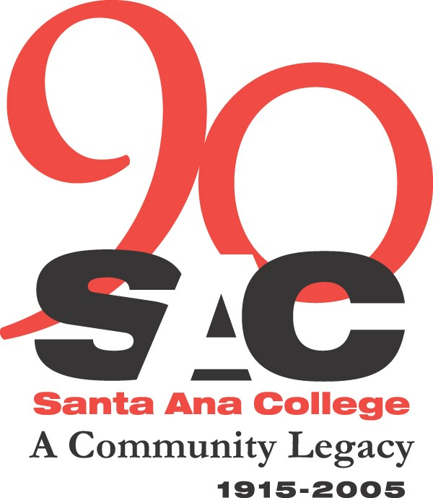

For Immediate Release
September 13, 2005

CONTACT:
Ruth Cossio-Muniz
(714) 564-6475
cossio_muniz_ruth@rsccd.org

Santa Ana College Celebrates its 90th Anniversary
Santa Ana, CA – Touting its rich history of academic excellence in the community, Santa Ana College (SAC) celebrates its 90th anniversary with a kick-off event on Wednesday, September 21. The celebration will take place at noon on the campus mall next to the amphitheater and will feature displays of famous alumni and events that have helped shape SAC’s history throughout the 90 years.
Students and the community can take part in contests to win prizes. There will also be free hot dogs and cake for everyone. In addition, the students activities division will host a Service Learning Fair from 9:30 a.m. to 2 p.m. to provide information from several community agencies and organizations in attendance; a blood drive will be sponsored by the Student Health Center; and the Associated Student Government will be collecting donations to contribute toward the Hurricane Katrina Relief efforts.

Continuing a History of Excellence
SAC was founded in 1915 and is a comprehensive community college under the Rancho Santiago Community College District. In 2004, SAC enrolled nearly 40,000 students in both credit and non-credit divisions combined. Known for its responsiveness to students and its commitment to innovation, SAC offers 150 concentrations or majors leading to the associate degree in science or arts. Students can also earn certificates of competency in over 100 occupational specializations and lower division transfer courses for advanced degrees at four-year colleges and universities. SAC offers career planning, counseling, childcare, financial aid, job placement, tutorial learning, disabled student programs, intercollegiate activities, library services, and health and wellness services.
(more)

SAC celebrates 90th anniversary 2/2

Expanding the Learning Environment
The passage of Measure E in November 2002 made $337 million available in local bond revenues to acquire land and undertake numerous construction and renovation programs at both SAC and Santiago Canyon College. The money will fund several projects at SAC including a new science building, Digital Media Center, Public Safety Institute, also known as the Orange County Sheriffs Academy, and the renovation of 14 campus buildings and infrastructures.

Alumni Achievements
Several SAC alumni have achieved soaring achievements to become actors, artists, legislators, chemists, professional athletes, teachers, etc. The list includes actress Diane Keaton, a graduate from SAC’s theater arts program, who won an Academy Award for her role in Annie Hall and was the star of the film Something’s Gotta Give. Corie Blount played forward center for the SAC Dons men’s basketball team and went on to play professionally in the NBA for the Chicago Bulls, Los Angeles Lakers, and currently for the Toronto Raptors. In 1977, Gaddi Vasquez graduated from SAC with a degree in criminal justice administration. He later moved up the ranks with several positions in the city, county, state and federal levels of government and was nominated and sworn in by President George W. Bush in 2002 to become the director of Peace Corps – the position he holds today.

Santa Ana College and Santiago Canyon College are public community colleges of Rancho Santiago Community College District, which serves the residents of Anaheim Hills, Garden Grove, Irvine, Orange, Santa Ana, Tustin and Villa Park. Both colleges provide education for academic transfer and careers, courses for personal and professional development, and customized training for business and industry.

# # #

