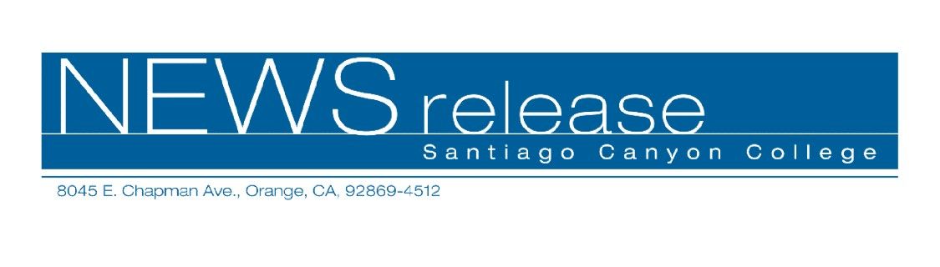
FOR RELEASE: IMMEDIATELY
CONTACT: ANNMARIE DEASY
714-628-4745
deasy_annmarie@sccollege.edu

Learn How to Become a Working Commercial Actor

July 22—Many people have dreams of acting professionally, but don’t know how to get started. Santiago Canyon College’s Community Services program offers
“Acting for Commercials,” designed to help beginning and intermediate actors get an edge in this highly competitive business. The one-day workshop will be held on Saturday, July 30 from 10:00 a.m. to 3:00 p.m. at Santiago Canyon College, room D-121.
Using actual commercial scripts, participants will learn the basics of working in front of the camera, including script analysis, vocal technique, and physical presentation. Students will also learn about the business of acting, including resumes, photos, and getting an agent. In addition, students will be invited to participate as background actors in the cable television show “Heartbreak Café.”
Robert Conrad, instructor of “Acting for Commercials” explained that the workshop is suited for a variety of students. “Some people just want to have fun with acting and others want to get into the industry but don’t know how to do it,” said Conrad.
An actor and producer, Conrad is the current director of “Heartbreak Café.” He has taught television and film studies throughout his 20-year career in the motion picture industry and has done production work for Disney, Paramount, and Time Warner. His past students have appeared in national commercials, television shows including Days of Our Lives, and in the movies Mystic River and The Abyss.
“Acting for Commercials” is scheduled for Saturday, July 30 from 10:00 a.m. to 3:00 p.m. at Santiago Canyon College, room D-121. The college is located at 8045 E. Chapman Avenue in Orange. The workshop is $49 and there is a $3 material fee payable at the door.

For more information on these or other Community Services classes, call (714) 628-4960 or visit www.sccollege.edu/cs.
Santiago Canyon College is a public community college of Rancho Santiago Community College District serving the residents of Anaheim Hills, Irvine, Orange, Tustin and Villa Park. The college provides education for academic transfer and careers, courses for personal and professional development, and customized training for business and industry.

###

