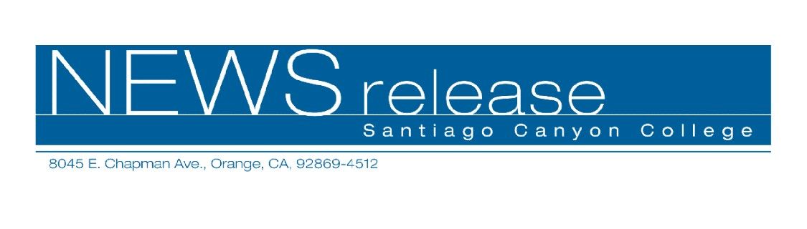
FOR RELEASE: IMMEDIATELY
CONTACT: ANNMARIE DEASY
714-628-4745
deasy_annmarie@sccollege.edu

Sharpen Your Acting and Comedy Skills
at Santiago Canyon College
June 23—Many people have dreams of performing on stage or in front of a camera. Some are interested in acting while others hope to make it as standup comedians. Santiago Canyon College offers two classes designed to give aspiring performers a chance to hone their acting and comedy skills.
“Acting for Commercials” is for beginning and intermediate actors looking to break into commercials. Using actual commercial scripts, participants will learn the basics of working in front of the camera including script analysis, vocal technique, and physical presentation. Students will also learn about the business of acting, including resumes, photos, and getting an agent. In addition, students will be invited to participate as background actors in the cable television show “Heartbreak Café.”
Robert Conrad, instructor of “Acting for Commercials” explained that the workshop is suited for a variety of students. “I get some people who want to have fun with acting and others who want to get into the industry but don’t know how to do it,” said Conrad.
Conrad is an actor, producer, and the current director of “Heartbreak Café.” He has taught television and film studies throughout his 20-year career in the motion picture industry and has done production work for Disney, Paramount, and Time Warner. Past students of Conrad’s have appeared on television in national commercials as well as television shows like Days of Our Lives and in the movies Mystic River and The Abyss.
“Acting for Commercials” is scheduled for Saturday, July 30 from 10:00 a.m. to 3:00 p.m. at Santiago Canyon College, room D-121, 8045 E. Chapman Ave., Orange. The fee for this workshop is $49 and there is a $3 material fee payable at the door.
For others who feel that comedy is their forte, “Becoming a Standup Comic” may be of interest. Students will learn the fundamentals of standup comedy, including the techniques and nuances, joke construction, comedic theory, creating a monologue, marketing their own comedy, and producing their own comedy shows. Students are encouraged to bring video cameras to the final class where they will showcase their talents at the Don Cribb Theater in Santa Ana, a professional comedy club.
The workshop is offered in six Tuesday sessions from July 12 to August 16, 7:00 p.m. to 9:30 p.m. at Orange Education Center, room 140, 1465 N. Batavia, Orange. Barry Weisenberg, a professional comedian who has been performing standup comedy for over 13 years, leads the workshop. Weisenberg has performed standup at a variety of venues including The Comedy Store and The Improv. The fee for this series of workshops is $105.
For more information on these or other Community Services classes, call (714) 628-4960 or visit www.sccollege.edu/cs.
Santiago Canyon College is a public community college of Rancho Santiago Community College District serving the residents of Anaheim Hills, Irvine, Orange, Tustin and Villa Park. The college provides education for academic transfer and careers, courses for personal and professional development, and customized training for business and industry.

###

