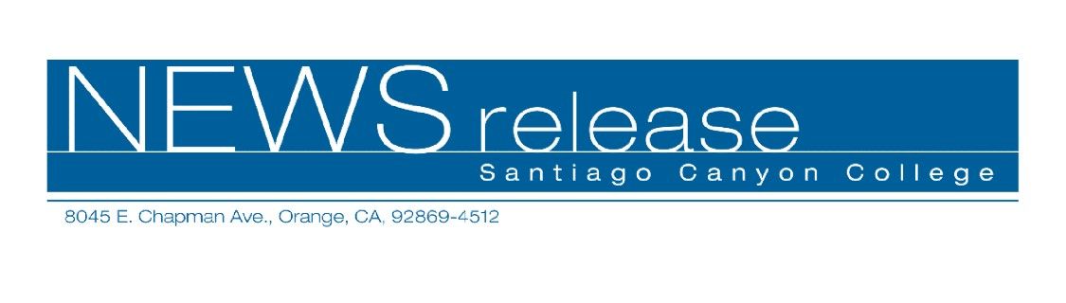
FOR RELEASE: IMMEDIATELY
CONTACT: ANNMARIE DEASY
714-628-4745
deasy_annmarie@sccollege.edu
Enjoy Spring Bungalow HeavenTM Home Tour

March 31— Spend a relaxing day visiting one of Southern California’s most beautiful and unique historic neighborhoods, Pasadena’s Bungalow HeavenTM. Santiago Canyon College’s Community Services Program makes this April 24 day trip convenient and comfortable. Depart from Orange at 9:00 a.m. for the motor coach ride to Pasadena. Enjoy the self-guided walking tour that includes six beautifully preserved Craftsman bungalows, as well as lecture presentations on the American arts and crafts movement, decorating with arts and crafts metalwork, and more. Lunch at a local restaurant in Pasadena is also included in the $69 per person registration fee.
The Bungalow HeavenTM neighborhood contains one of the largest concentrations of intact Craftsman bungalows in the U.S. The neighborhood has been featured on HGTV and in numerous publications, including the Los Angeles Times, USA Today, the New York Times, Sunset, Los Angeles and American Bungalow magazines as well as the new book entitled Bungalow Nation. The Bungalow HeavenTM home tour only happens once a year—you don’t want to miss it!

--more--

Pasadena Bungalow HeavenTM Home Tour Page 2 of 2

Please note that because of the historic nature of these homes, there is no disabled access. Participants are required to travel on the motor coach and must be at least 18 years old. The tour departs from Santiago Canyon College’s parking lot 2 at 9:00 a.m. sharp on Sunday, April 24, and returns at 5:00 p.m.
To register for the Pasadena Bungalow HeavenTM Home Tour, contact the community services program office at (714) 628-4960 or visit us online at www.rsccd.org/cms.
Santiago Canyon College is located at 8045 E. Chapman Avenue in Orange, at the corner of Chapman and Newport. It is a public community college of Rancho Santiago Community College District serving the residents of Anaheim Hills, Irvine, Orange, Tustin and Villa Park. The college provides education for academic transfer and careers, courses for personal and professional development, and customized training for business and industry.

###

