

NEWS
July 13, 2004

Contact: Ruth Cossio-Muniz

Communications Specialist For Immediate Release
Phone: (714) 564-6475
Cell: (714) 401-7884
cossio_muniz_ruth@rsccd.org

Ballet Folklorico class to perform at the Orange County Fair
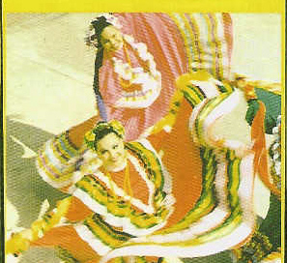
Santa Ana, CA – Student dancers from Santa Ana College’s advanced folklorico class, who are members of the Ballet Mexicanisimo dance company, prepare to showcase their talent at the Orange County Fair on Saturday, July 24, as part of the Worldwide Celebration of the Mariachi concert held at the Pacific Coast Amphitheatre beginning at 6 p.m.
Trained and directed by adjunct faculty member Graciela Hinojosa, the dance group currently consists of 24 dancers. The repertoire reflects the diversity of Mexican Folkloric dance from the European influences in the North, to the Afro-Caribbean influences in the South. In each performance, a cross reference of Mexico is seen as each State from Mexico is depicted by its respective regional dances.
Ballet Mexicanisimo has been invited to participate in many events including, recently, at the Performing Arts of Orange County for the 100th Anniversary of Mariachi Vargas de Tecalitlan, known as the best mariachi in the world.
Hinojosa performed for both the world renowned Ballet Folklorico de Amalia Hernandez and the prestigious Ballet Folklorico de la Universidad de Guadalajara. She is an advocate for traditional culture and is well known at folkloric dance events throughout the United States and Mexico. Currently, she is a dance professor at Santa Ana College and Los Angeles Trade Technical College.
For more information about Ballet Mexicanisimo, contact the Santa Ana College Fine & Performing Arts Division at (714) 564-6600. Tickets to see the Mariachi concert range from $45 to $78. To purchase tickets, or for more information, visit www.ocfair.com.
# # #

