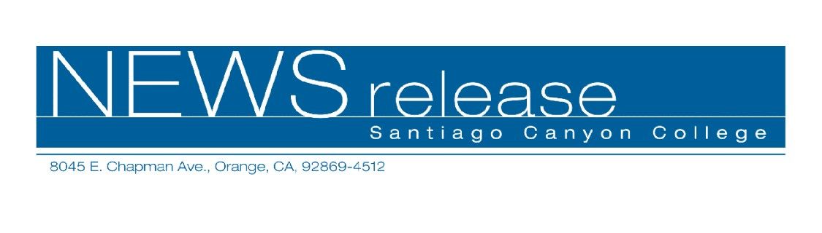
FOR RELEASE: IMMEDIATELY
CONTACT: ANNMARIE LIBRESCU
714-628-4745
librescu_annmarie@sccollege.edu

Be Your Own Private Investigator
April 3— Did you know that in California you don’t need a license to conduct private investigations, as long as you’re doing them for yourself? Think of all the possibilities if you only knew where to find the information. You can learn the basics in one evening by attending “How to Be Your Own Private Investigator,” a seminar offered by Santiago Canyon College’s Community Services program.
Some of the many applications of being your own private investigator include collecting on financial judgments owed to you, doing background checks, and investigating a spouse or partner.
“How to Be Your Own Private Investigator” is taught by Jim Harriger, a retired Los Angeles police officer with over 37 years of investigative experience. A licensed private investigator, insurance fraud investigator and criminal justice instructor, Harriger has been teaching for over 13 years.
“This class is for people who want to save money by doing their own investigations,” Harriger said. “The biggest secret is knowing where the information is, and that’s what I go over in the class.”
“How to Be Your Own Private Investigator” will be held on Tuesday, April 11 from 6:30 to 9:30 p.m. at Santiago Canyon College, Room U-99. The college is located at 8045 E. Chapman Avenue in Orange.
The fee for the seminar is $39, with an optional workbook that may be purchased for $25 in class. For more information on this or other Community Services classes, call (714) 628-4960 or visit www.sccollege.edu/cs.
Santiago Canyon College is a public community college of Rancho Santiago Community College District serving the residents of Anaheim Hills, Irvine, Orange, Tustin and Villa Park. The college provides education for academic transfer and careers, courses for personal and professional development, and customized training for business and industry.

###

