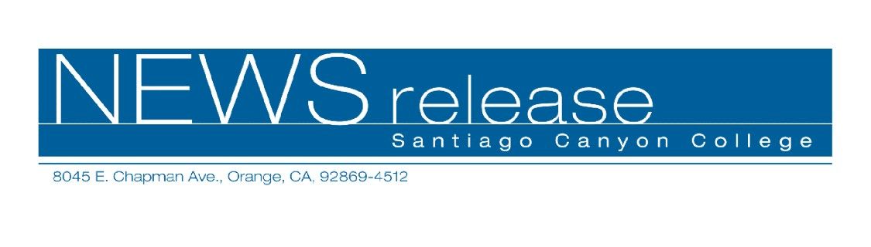
FOR RELEASE: IMMEDIATELY
CONTACT: ANNMARIE DEASY
714-628-4745
deasy_annmarie@sccollege.edu

Become a Notary Public in One Day!
June 3—Becoming a notary is more lucrative today than ever. A notary can earn hundreds of dollars a day by notarizing documents for legal and professional industries, and working with signing services.
With new regulations for California notaries taking effect on July 1, Santiago Canyon College’s Community Services Program is offering “Become a Notary in One Day!” on Saturday, June 18 from 8:00 a.m. to 6:00 p.m. in room D-216 at Santiago Canyon College, 8045 E. Chapman Ave., in Orange.
In this workshop participants will learn how to be reliable and effective notaries. Students will learn how to fill out certificates and journal entries, identify document signers, avoid lawsuits and understand all the laws and regulations required by the state of notary publics.
Participants will learn all they need to know to pass the state examination that will be given immediately after the seminar. Students will check in for the exam from 4:00 p.m. to 5:00 p.m. and the exam will run from 5:00 p.m. to 6:00 p.m. To take the state exam, you must be a legal resident of the state of California (military excluded) and at least 18 years of age. To be licensed as a notary, you must pass the test and pass a background check. The state requires students to be present for the entire six-hour course to receive proof of completion. Students who arrive after 8:30 a.m. will not be admitted.
The class fee is $85 and a $20 material fee is payable in class. In addition, the state requires new applicants and renewals to pay a fee of $40 payable to the Secretary of State. Applicants must show a driver’s license or state photo I.D. Students must pre-register as space is limited.
For more information on this or Community Services classes, call (714) 628-4960 or visit www.sccollege.edu/cs.
Santiago Canyon College is a public community college of Rancho Santiago Community College District serving the residents of Anaheim Hills, Irvine, Orange, Tustin and Villa Park. The college provides education for academic transfer and careers, courses for personal and professional development, and customized training for business and industry.

###

