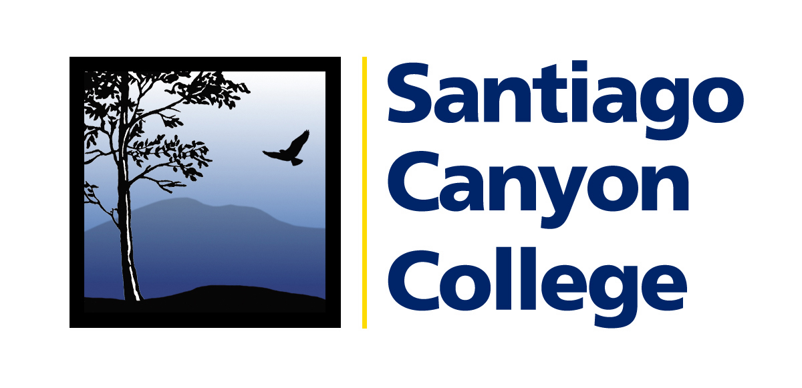

Calendar Listing

Media Contact: AnnMarie Librescu
(714) 628-4745 librescu_annmarie@sccollege.edu

Santiago Canyon College Continuing Education Hosts Free Citizenship Application Workshop

WHAT: On Saturday, September 27, Santiago Canyon College’s Continuing Education citizenship program will host a free day-long event to help community members complete the N-400 citizenship application. Training for volunteer citizenship workers will be provided in advance as part of the Ya Es Hora…¡Ciudadanía! campaign.

Participants should bring their green card, social security card, California state identification card, or driver’s license.

WHEN: Saturday, September 27, 2008
9:00 a.m. to 3:00 p.m.
No appointment or reservation is necessary—walk-ins are welcome.

WHERE: El Modena Family Resource Center, 18672 E. Center St., Orange 92869

WHY: This is the last chance to turn in citizenship applications before the new test takes effect on October 1, 2008.

PRICE: FREE!

CONTACT: Tom Donahoe, citizenship coordinator, (714) 628-5928.

About Santiago Canyon College’s Continuing Education Division:
The dedicated faculty and staff of the continuing education division provide free classes and services to over 10,000 people each year. Free, non-college credit class offerings include computer instruction, health and safety, English as a Second Language, adult basic education, parenting skills, high school and GED programs, and more. The main instructional location is the Orange Education Center, located at 1465 N. Batavia, Orange 92867, (714) 628-5900.

Free citizenship workshops are held every month at:
Orange Education Center, 1465 N. Batavia, Orange 92867, (714) 628-5900
- First and third Saturdays, 12:00-2:00 p.m., second and fourth Tuesdays of the month, 4:00-6:00 p.m.

# # #

