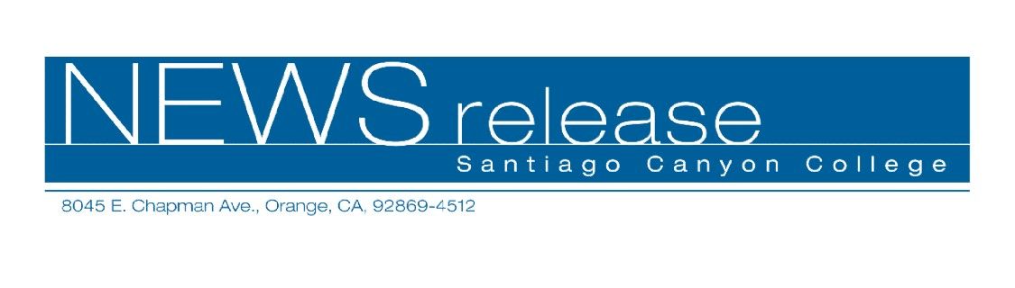
FOR RELEASE: IMMEDIATELY
CONTACT: ANNMARIE LIBRESCU
714-628-4745
librescu_annmarie@sccollege.edu

Coaching and Consulting Career Class Offered
March 21—Demand for life coaches, consultants and trainers has never been greater. You can enter this lucrative field by using the knowledge and skills gained through education, employment and life experiences. Santiago Canyon College’s Community Services program offers “Coaching, Consulting and Training,” a new class designed to help you begin your own full- or part-time business.
Having your own coaching, consulting or training business offers you freedom, financial gain and the satisfaction of knowing that you’re helping others to reach their full potential. In “Coaching, Consulting and Training” you’ll learn the different types of coaching and consulting careers available as well as tax write-offs, legal issues, preparing proposals and contracts, locating clients and structuring your fees. Discover low- and no-cost methods to promote your business.
The class is taught by Mike Rounds, an instructor with a diverse business background and 30 years of experience. “Coaching, Consulting and Training” will be held on Thursday evening, March 30 from 6:30-9:30 p.m. at Santiago Canyon College, building B, room 213. The college is located at 8045 E. Chapman Avenue in Orange.
The class cost is $39 plus a $20 material fee payable in class. For more information or to register, call (714) 628-4960 or visit www.sccollege.edu/cs.
Santiago Canyon College is a public community college of Rancho Santiago Community College District serving the residents of Anaheim Hills, Irvine, Orange, Tustin and Villa Park. The college provides education for academic transfer and careers, courses for personal and professional development, and customized training for business and industry.

###

