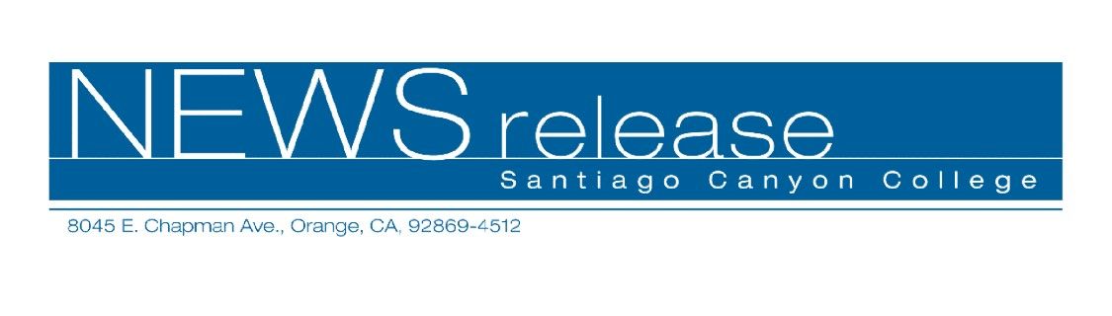
FOR RELEASE: IMMEDIATELY
CONTACT: ANNMARIE DEASY
714-628-4745
deasy_annmarie@sccollege.edu

College for Kids and Teens Offers Art and Computer Classes During July and August

June 8—Santiago Canyon College Community Services Program offers College for Kids and Teens, a wide variety of classes for students ages 8 to 15. Classes are designed to challenge students’ imaginations and inspire creativity. Students can improve academic skills and develop self-confidence while making new friends.
“Design Your Own Website,” teaches students ages 8 through 14 how to create their own websites. During instruction in web design and layout, students will learn how to insert text, favorite images, backgrounds, graphics, and more. Instruction will also be provided showing students how to download their completed website to a disk or CD and post it onto the Internet from their home computers. Students should bring a blank CD, a Zip disk, or a re-writeable disk to class or they may purchase these items for $5 in class.
The workshop is offered during two different sessions. The first session takes place Monday through Thursday, July 11 through July 14 from 1 p.m. to 4 p.m. The second session takes place Monday through Thursday, August 1 through August 4 from 1 p.m. to 4 p.m. Both workshops are held at Santiago Canyon College, room B-106, 8045 E. Chapman Ave., in Orange. The fee for each session is $78. Classes are filling up quickly so sign up now. Magdalena Salazar-Fukuda, a computer instructor with Rancho Santiago Community College District, teaches the workshops.
In “Animation Art,” students ages 8 thought 12 will experiment with animation process similar to how original cartoons are created. Techniques that will be taught include exaggerating features and figures and drawing characters in motion. Students will paint backgrounds and develop comic characters that will be placed together onto an acetate cell that can be framed and displayed. Parent volunteers are welcome in class.
The workshop is offered during two different sessions. The first session takes place Monday through Friday, July 18 through July 22 from 3 p.m. to 4:30 p.m. The second session takes place Monday through Friday, August 15 through August 19 from 3 p.m. to 4:30 p.m. Both workshops are held at Santiago Canyon College, room D-110. The fee for each session is $59 with a material fee of $15 payable at the door. Romma Ith, an artist and cartoonist who has taught youth programs for the city of Santa Ana, leads the workshops.
For more information on College for Kids and Teens or other Community Services classes, call (714) 628-4960 or visit www.sccollege.edu/cs.
Santiago Canyon College is a public community college of Rancho Santiago Community College District serving the residents of Anaheim Hills, Irvine, Orange, Tustin and Villa Park. The college provides education for academic transfer and careers, courses for personal and professional development, and customized training for business and industry.

###

