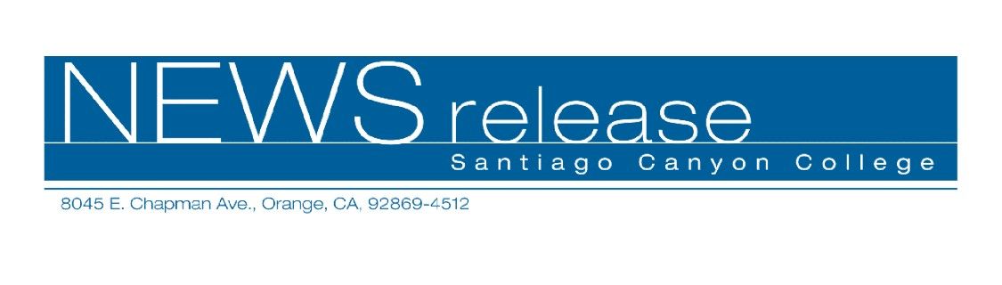
FOR RELEASE: IMMEDIATELY
CONTACT: ANNMARIE DEASY
714-628-4745
deasy_annmarie@sccollege.edu

College for Kids and Teens Offers Creative Classes for Students During June

June 8—Santiago Canyon College Community Services Program offers College for Kids and Teens, a wide variety of classes for students ages 8 to 15. Classes are designed to challenge students’ imaginations and inspire creativity. Students can improve academic skills and develop self-confidence while making new friends.
In “Photoshop for Kids” students who want to merge their creative skills with technology are provided with 12 hours of instruction introducing them to the magic of Photoshop, the most advanced photo and artwork manipulation program on the market today. The class is designed for students ages 8 through 12 and basic computer and scanning knowledge is recommended. During the class, students will be taught how to sharpen and color correct photographs, repair damaged images, and combine two or more photos into one. Students will create artwork with photographs, add text to photographs, and create greeting cards with a personal touch. Students should bring photographs to edit and a Zip disk, which they will have the option of purchasing for $10 in class.
“Photoshop for Kids” takes place Monday through Thursday from June 27 through June 30 from 1 p.m. to 4 p.m. at Santiago Canyon College, room B-106, 8045 E. Chapman Ave., in Orange. The cost of the workshop is $78. Volker Thorey, an instructor at Santa Ana College who has taught College for Kids and Teens for the past six years, teaches the workshop.
“Draw! Paint! Make Prints!” is a hands-on workshop where students will study Da Vinci, Bellini, Michelangelo and other Renaissance artists and create inspired pieces of art. Budding artists will learn basic techniques and skills to master drawing, painting, and printmaking.
The workshop is offered during two different sessions in June. The first session takes place Monday through Thursday, June 20 through June 23 from 9 a.m. to 10:30 a.m. The second session takes place Monday through Thursday, June 27 through June 30 from 9 a.m. to 10:30 a.m. Both workshops are held at Santiago Canyon College, room D-110 and the fee for each session is $54 and a $12 materials fee is payable at the door. Jennifer Cristini, an art instructor at Bowers Kidseum in Santa Ana, teaches the workshops.
For more information on College for Kids and Teens or other Community Services classes, call (714) 628-4960 or visit www.sccollege.edu/cs.
Santiago Canyon College is a public community college of Rancho Santiago Community College District serving the residents of Anaheim Hills, Irvine, Orange, Tustin and Villa Park. The college provides education for academic transfer and careers, courses for personal and professional development, and customized training for business and industry.

###

