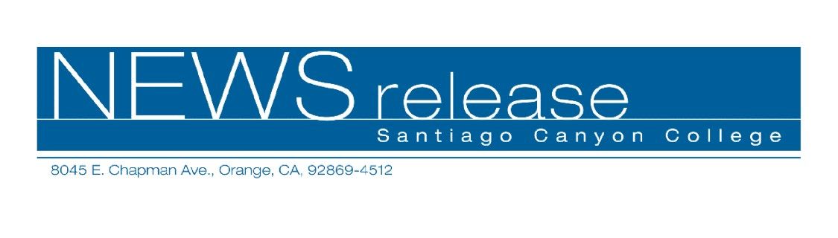
FOR RELEASE: IMMEDIATELY
CONTACT: ANNMARIE LIBRESCU
714-628-4745
librescu_annmarie@sccollege.edu

Fun Summer Classes for Kids and Teens
May 8—Are you looking for summer activities that your children will enjoy? Keep them active and learning all summer long with Santiago Canyon College’s Community Services program. College for Kids and Teens is offered for children aged 8-16 throughout June, July and August. Choose from over fifty classes from A (acting) to Z (zoo camp) and everything in between!
“This summer we’re excited to offer many new classes in the College for Kids and Teens program,” said Maureen Cleary, Community Services program coordinator. “Whether your child is interested in dance, music, art or magic, we’ve got something that will appeal to everyone.”
College for Kids and Teens classes include traditional “summer school” subjects such as writing, math, and reading development that will help children when they return to school. Other subjects are fun and practical, such as learning how to ride a horse, play tennis or become a seriously awesome babysitter.
Registration for College for Kids and Teens classes is now underway and space is limited. Check out the summer class brochure online at www.sccollege.edu/cs or call (714) 628-4960 for more information. Most classes are held at Santiago Canyon College, which is located at 8045 E. Chapman Avenue in Orange.
Santiago Canyon College is a public community college of Rancho Santiago Community College District, serving the residents of Anaheim Hills, Irvine, Orange, Tustin and Villa Park. The college provides education for academic transfer and careers, courses for personal and professional development, and customized training for business and industry.

###

