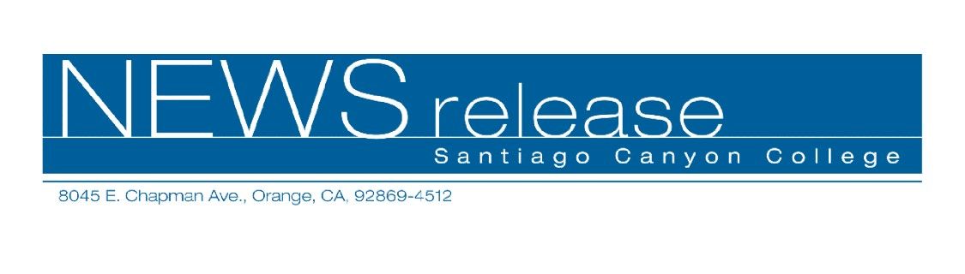
FOR RELEASE: IMMEDIATELY
CONTACT: ANNMARIE DEASY
714-628-4745
deasy_annmarie@sccollege.edu
Fall Community Services Program Begins September 8
August 30—Expand your horizons this fall with a fun community services class in Orange, Anaheim or Santa Ana. Choose from an extensive selection of over 125 classes offered by Santiago Canyon College’s Community Services Program, including personal enrichment, professional and career development, recreation and travel opportunities.
The fall program begins September 8. “We offer an array of unique classes that promote lifelong learning to our diverse community, including our College for Kids Program,” said Maureen Cleary, community services coordinator. “New classes this fall include writing for magazines, Japanese cuisine, stretching your household budget to make ends meet, a barbeque and hayride in Oak Glen and much more!”
For a complete listing of class offerings visit our website at www.sccollege.edu/cs, or call (714) 628-4960 for a brochure and registration information.
Santiago Canyon College is a public community college of Rancho Santiago Community College District which serves the residents of Anaheim Hills, Irvine, Orange, Tustin and Villa Park. The college provides education for academic transfer and careers, courses for personal and professional development, and customized training for business and industry.
###

