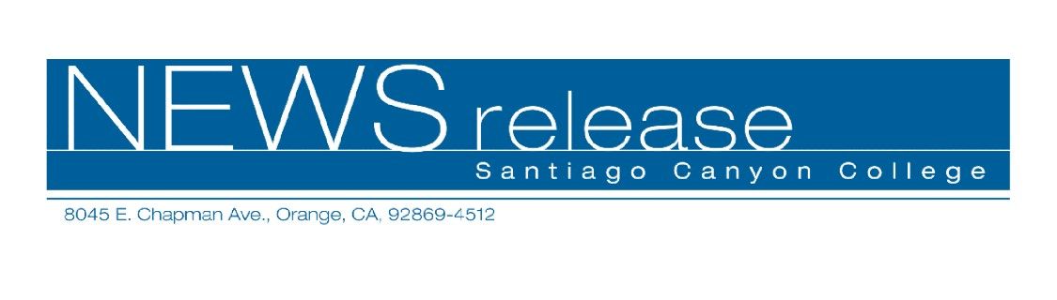
FOR RELEASE: IMMEDIATELY
CONTACT: ANNMARIE LIBRESCU
714-628-4745
librescu_annmarie@sccollege.edu
Nightclub Dance and Swing Classes in Orange
April 3—Want to burn some calories and have fun at the same time? Sign up for a dance class (or two) and find out how easy it is to get comfortable on the dance floor. Santiago Canyon College’s Community Services program offers “Swing Dance—West Coast” and “Nightclub Dancing” on Friday evenings beginning April 14. No partner is necessary for either class.
In “Nightclub Dancing,” you’ll learn steps set to a variety of music. Dances taught include the slow, romantic two-step as well as some swing dance basics. The nightclub cha-cha and waltz will also be covered.
In “Swing Dance—West Coast,” you’ll learn the stylish, sophisticated steps of the swing and some basic techniques such as how to lead and follow a partner.
The instructor for both classes is Larry Martin, who has taught dance for over 18 years and competed in the National Swing Championships. Attire for dance classes is casual dress, tennis or soft soled shoes (no hard heels permitted).
Both dance classes are held on six consecutive Friday evenings, April 14 through May 19. Times and class fees are as follows:
- “Nightclub Dancing” is $59 per person and begins April 14 from 6:30-7:45 p.m.
- “Swing Dance—West Coast” is $59 per person and begins April 14 from 8:00-9:15 p.m.
Both classes are held in room D-125 at Santiago Canyon College, located at 8045 E.
Chapman Avenue in Orange. To register, obtain more information or get directions, call (714) 628-4960 or visit the web site at www.sccollege.edu/cs.

—more—
Nightclub Dance and West Coast Swing Page 2 of 2

Santiago Canyon College is a public community college of Rancho Santiago Community College District, serving the residents of Anaheim Hills, Irvine, Orange, Tustin and Villa Park. The college provides education for academic transfer and careers, courses for personal and professional development, and customized training for business and industry.

###

