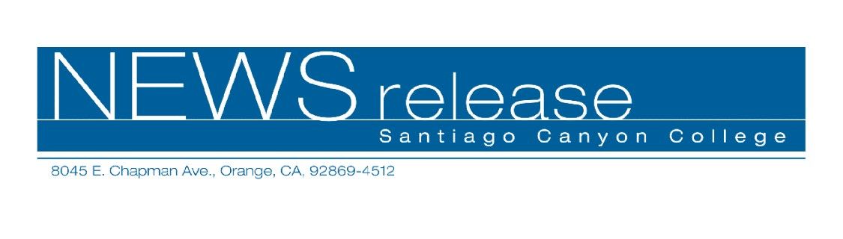
FOR RELEASE: IMMEDIATELY
CONTACT: ANNMARIE LIBRESCU
714-628-4745
librescu_annmarie@sccollege.edu
Catch the Dance Craze in 2006
January 30—Keep your New Year’s resolution to exercise and have fun at the same time! Dancing is a great way to burn calories, and Santiago Canyon College’s Community Services program offers several classes to choose from in February. No partner is necessary for “Ballroom Blitz” and “Swing Dance—East & West Coast” classes that begin on Friday evening, February 3. Bring your future spouse and learn how to “Dance at Your Wedding,” on Saturday, February 11.
You’ll learn the waltz, foxtrot, cha-cha and rumba in “Ballroom Blitz.” This six-session class meets from 6:30-7:45 p.m. on Friday evenings, February 3-March 17.
If East Coast jitterbug is more your style, sign up for Session A of “Swing Dance—East & West Coast.” The class meets on Friday evenings from February 3-March 17, 8:00-9:15 p.m.
Get ready for your wedding (or someone else’s) when you sign up for “Dance at Your Wedding.” Learn basic steps, simple turns and other techniques that will have you dancing with confidence in just one three-hour session on Saturday, February 11 from 2:00-5:00 p.m.
The instructor for all three classes is Larry Martin, who has taught dance for over 18 years and has competed in the National Swing Championships.
The attire for dance classes is casual dress, tennis or soft soled shoes (no hard heels permitted). The fee for “Ballroom Blitz” is $59. The class meets on Friday evenings, February 3-March 17 from 6:30-7:45 p.m. “Swing Dance—East & West Coast” is $59 and also meets on Friday evenings, February 3-March 17, from 8:00-9:15 p.m. The fee for “Dance at Your Wedding” is $29, and the class is this Saturday, February 11 from 2:00-5:00 p.m. All classes are held in room D-125 at Santiago Canyon College, 8045 E. Chapman Avenue in Orange.
To register, obtain more information or get directions, call (714) 628-4960 or visit the web site at www.sccollege.edu/cs.
--more--
Catch the Dance Craze in 2006 Page 2 of 2

Santiago Canyon College is a public community college of Rancho Santiago Community College District, serving the residents of Anaheim Hills, Irvine, Orange, Tustin and Villa Park. The college provides education for academic transfer and careers, courses for personal and professional development, and customized training for business and industry.

###

