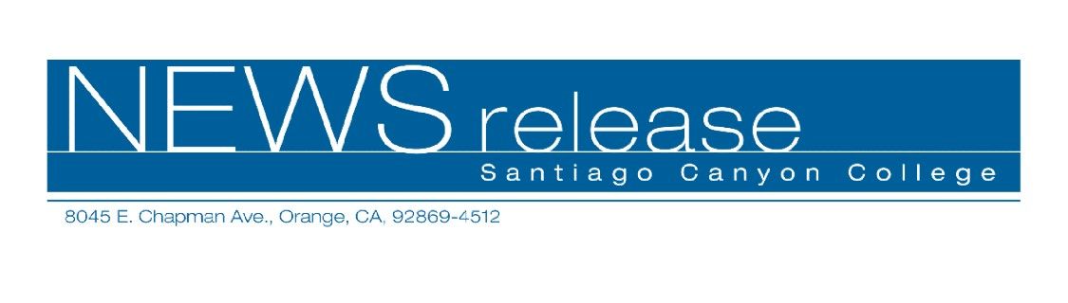
FOR RELEASE: IMMEDIATELY
CONTACT: ANNMARIE DEASY
714-628-4745
deasy_annmarie@sccollege.edu
Santiago Canyon College Offers New Digital Media Arts Certificate Program

July 13— This fall Santiago Canyon College unveils its newest cutting-edge professional certificate program in digital media arts (with an emphasis in graphic design). The new certificate reflects the rapidly changing world of advertising and graphic design and integrates the latest techniques in web design and motion graphics. The program provides a combination of fine art and digital media courses to enhance students’ technical skills and creativity. A final capstone project enables students to demonstrate their digital media arts skills and produce design pieces that can be used to build their professional portfolios.
Faculty members who are experts in their fields teach courses in the certificate program, including ART 121 A and B (fundamental and advanced typography), ART 122 (graphic design), ART 162 (digital design with Photoshop) and ART 195 (introduction to digital design). Design coursework is completed on brand new, state-of-the-art Apple Power Macintosh G5 computers and the latest software applications, including Photoshop, Indesign, Illustrator and Quark.
“We’re excited to offer this new certificate program to prepare students for employment in advertising, graphic design, the printing industry and e-commerce,” said Mary McMullin, Dean of Arts, Humanities and Social Sciences at Santiago Canyon College.
Classes are conveniently offered during daytime, evening and weekend hours. Santiago Canyon College also offers art curriculum leading to an associate degree or transfer to four-year colleges and universities.

--more--
Santiago Canyon College Offers New Digital Media Arts Certificate 2 of 2

For more information about enrolling in Santiago Canyon College’s new certificate in digital media arts program, please call (714) 628-4820 or visit the web site at
www.sccollege.edu. The fall semester begins on Monday, August 23, and registration for new students begins Monday, August 9. Application, registration and text book purchase can be completed online at www.sccollege.edu, or call (714) 628-4900 for more information.
Santiago Canyon College and Santa Ana College are public community colleges of Rancho Santiago Community College District which serves the residents of Anaheim Hills, Garden Grove, Irvine, Orange, Santa Ana, Tustin and Villa Park. Both colleges provide education for academic transfer and careers, courses for personal and professional development, and customized training for business and industry.

###

