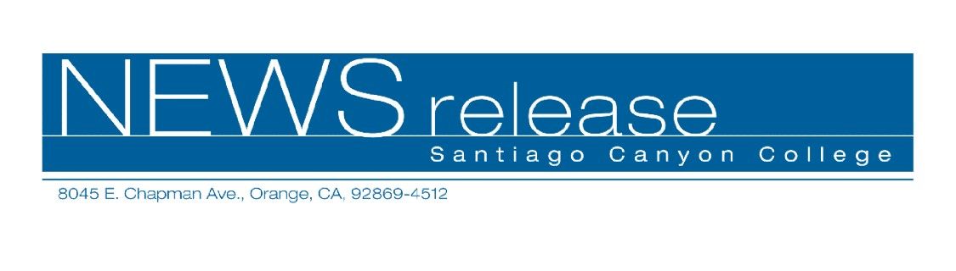
March 13, 2009
FOR IMMEDIATE RELEASE
Contact: AnnMarie Librescu, PIO
714-628-4745
librescu_annmarie@sccollege.edu
College Orientation Program Wins National Award
“Discover SCC” is named Innovative New Program

Orange—Santiago Canyon College’s Discover SCC: Orientation to College Life program was selected by the American College Personnel Association’s (ACPA) Commission for Student Development in the Two-Year College to receive the Innovative New Program award. Staff members and colleagues who submitted the program for consideration will travel to Maryland to accept the award on March 28 at the ACPA Annual Convention. In addition, they will provide a presentation to convention attendees on the award-winning program.
Discover SCC was started in 2006 to give new freshmen an overview of the programs and services offered at Santiago Canyon College. Led by current students trained as orientation leaders, the program allows the new students to connect with their peers and boosts their confidence about starting college.
“While these types of college life orientation programs are common at four-year universities, they are rare within the California community college system,” said Vice President of Student Services Dr. John Hernandez. “Discover SCC was developed as a response to research data that indicated our incoming students didn’t feel connected to campus life. More than 400 students have participated in the program, and their evaluations have been overwhelmingly positive.”
The half-day Discover SCC program includes workshops on college programs and services to help students be successful, small group activities such as icebreakers and campus tours, and concludes with lunch. The Innovative New Program Award recognizes Santiago Canyon College’s half-day orientation as a program to be modeled by other two-year colleges in the U.S.

--more--
College Orientation Program Wins Award 2 of 2

Santiago Canyon College is a public community college, part of Rancho Santiago Community College District. According to Community College Week, Santiago Canyon College is the fourth fastest-growing public college of its size (enrollment of 10,000 or more) in the U.S. It serves the residents of Anaheim Hills, Orange, Tustin and Villa Park. The college provides education for academic transfer and careers, courses for personal and professional development, and customized training for business and industry.

# # #

