
Media Advisory

July 29, 2026

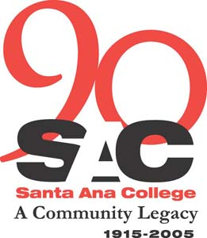

Marketplace Education Center Launches Free Education Fair

WHAT: In the heart of downtown Santa Ana, at the corner of Fourth and Bush streets, the Santa Ana College Marketplace Education Center (MEC) will launch its first ever Education Fair for the community. The event is staged to introduce local residents to the free educational classes and services offered at the facility.
Event includes tours and refreshments.

WHO: Marketplace serves a wide range of adult learners – from working parents who want to improve their English Language skills to help their children with homework to local employees who want to advance in their careers with additional technical training. The event is open to the public. Instructors and staff will be on site to answer questions about admissions and enrollment.

WHERE: The Marketplace Education Center
201 E. Fourth St., 2nd Floor
Santa Ana, CA 92701
(714) 564-5760
Free parking will be available.

WHEN: Saturday, April 29
10 a.m. to 2 p.m.

BACKGROUND: MEC is one of two Centers of Continuing Education operated by Santa Ana College. Classes, scheduled throughout the day, in the evenings and on Saturdays, are open exit/open entry, which means students can enroll at anytime. Sample courses include: English as a Second Language (ESL), Spanish literacy, high school subjects, GED test preparation, adult basic education, citizenship, computer training and vocational training. Counseling services are also available at no cost to residents.

NEWS INTEREST: MEC is conveniently located in the heart of Santa Ana for the hundreds of families who use public transportation, walk or bicycle around the city. The location was specifically identified for continuing education because of the population density and tremendous need for free college preparatory and career advancement coursework.

PHOTO OPPORTUNITIES: Hundreds of local adults and families exploring the facility, learning about the free coursework available at Marketplace Education Center.

CONTACT: Ruth Cossio-Muniz
SAC Public Information Coordinator
Phone: (714) 564-6475, Mobile: (714) 401-7884

