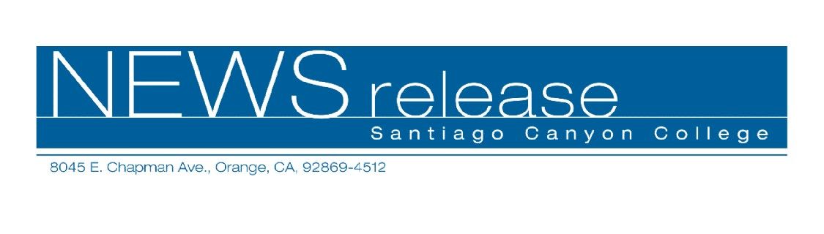
FOR RELEASE: IMMEDIATELY
CONTACT: ANNMARIE LIBRESCU
714-628-4745
librescu_annmarie@sccollege.edu

Santiago Canyon College Presents
“Heart and Soul of America” Concert

October 4—Santiago Canyon College’s Orange Community Master Chorale and Collegiate Choir will join forces to present the “Heart and Soul of America,” a fall concert of folk songs and spirituals. The concert takes place on Sunday, October 22, 4:00 p.m. at the First United Methodist Church of Orange, located at 161 South Orange in the City of Orange.
This concert for the entire family will feature the 100-voice combined choirs performing simple solo folk songs to intricate, eight-part spirituals. Featured percussion and woodwind players will accompany the ensembles. Songs in the program include “Lift Every Voice for Freedom,” “Rocking Jerusalem,” and works by composers Aaron Copeland, William Dawson, Hall Johnson, Moses Hogan, Jester Hairston and Andre Thomas.
“This will be a moving concert that audiences of all ages will enjoy,” said Michael Short, choir director. “These songs express pride in our American heritage. There will even be a sing-along of some of our most beloved folk songs.”
Tickets for this event are on sale now for $10 per person. Tickets are also available for purchase at the door the day of the concert. For information and to reserve tickets, please call (714) 213-5859.
Santiago Canyon College is a public community college of Rancho Santiago Community College District, which serves the residents of Anaheim Hills, Irvine, Orange, Tustin and Villa Park. The college provides education for academic transfer and careers, courses for personal and professional development, and customized training for business and industry.

# # #

