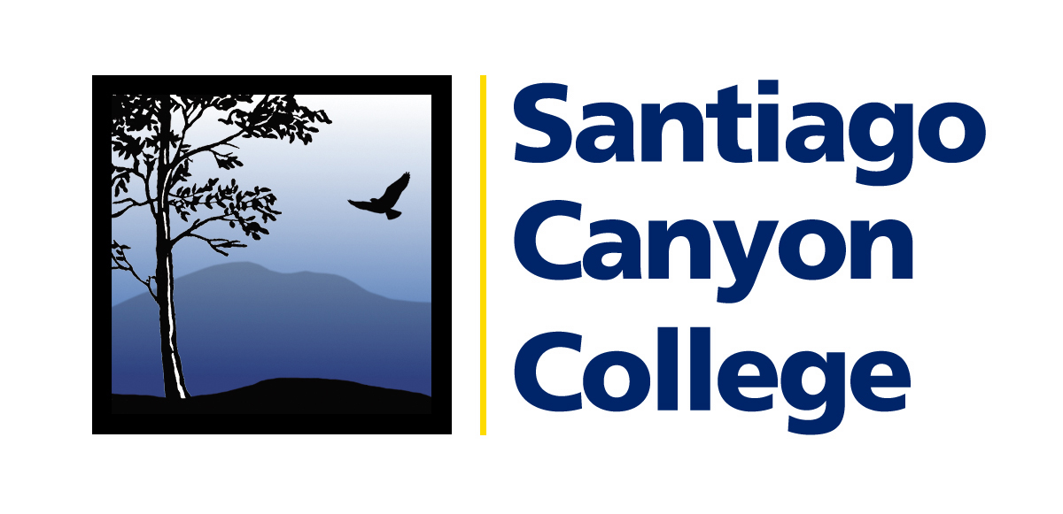

CALENDAR LISTING

Contact: AnnMarie Librescu
Phone: (714) 628-4745
E-mail: Librescu_annmarie@sccollege.edu

THE LOST BOYS OF SUDAN TELL THEIR STORY OF SURVIVAL IN HONOR OF THE YEAR OF THE LIBRARY
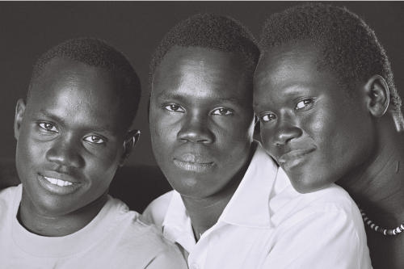

WHAT: To commemorate 2007 as the Year of the Library in the City of Orange, Santiago Canyon College Friends of the Library will host a book discussion with the co-authors and editor of They Poured Fire on us from the Sky: the True Story of Three Lost Boys of Sudan. A brief film will be shown that introduces the religious and ethnic conflict still taking place in Sudan. Following the film, co-authors and brothers Alphonsion and Benson Deng along with cousin Benjamin Ajak will tell their story of survival and how a relocation program to the United States brought them to San Diego where they currently attend college. Editor and co-author Judy A. Bernstein will also be present for discussion.

WHERE: Santiago Canyon College, 8045 E. Chapman Ave. in Orange, Building D, Room 121. Free
parking is available in all student lots.

WHEN: Wednesday, February 28, 1:00-2:30 p.m.

PRICE: Free Admission

CONTACT: For more information, contact Leah Freidenrich at (714) 628-5000 or e-mail Freidenrich_leah@sccollege.edu.
# # #

