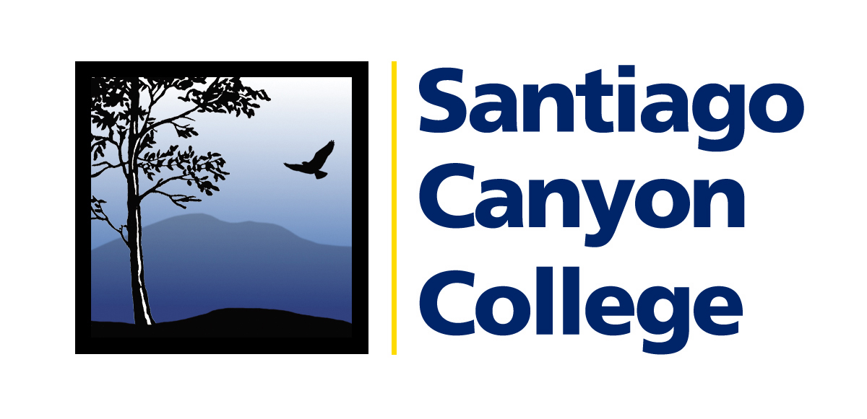

CALENDAR LISTING

Contact: AnnMarie Librescu
Phone: (714) 628-4745
E-mail: Librescu_annmarie@sccollege.edu

USED BOOKS IN DEMAND FOR NATIONAL LIBRARY WEEK BOOK SALE Hosted by the Santiago Canyon College Friends of the Library

WHAT: In celebration of National Library Week (April 15-21) the Santiago Canyon College (SCC) Friends of the Library are accepting gently used books through April 11. Donated books will be sold at the Friends first book sale to benefit the SCC Library, April 17-18.

WHERE: Used books can be dropped off at the Santiago Canyon College Library,
8045 E. Chapman Ave., Orange (at the corner of Chapman and Newport)
The April 17-18 book sale will be held in the college’s A/B Quad.
Free parking for the book sale is available in all student lots.

WHEN: Book drive extends through April 11.
Book sale is Tuesday and Wednesday, April 17-18, 9:00 a.m.-2:00 p.m.

PRICE: Books prices will vary

CONTACT: For more information, contact Linda Dressler (714) 628-5000 or via e-mail at dressler_linda@sccollege.edu.
# # #
About 2007 National Library Week, April 15-21: National Library Week promotes library use, fosters the growth of libraries and supports contributions to the community from librarians and library workers throughout the United States.

