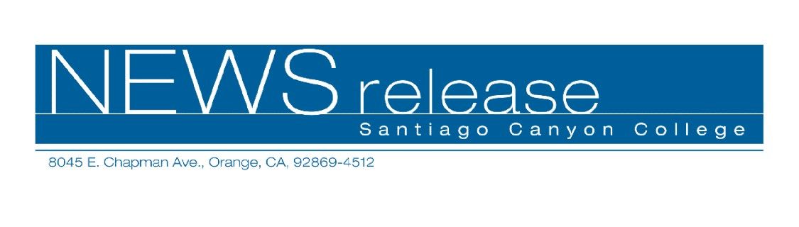
FOR RELEASE: IMMEDIATELY
CONTACT: ANNMARIE LIBRESCU
714-628-4745
librescu_annmarie@sccollege.edu
Learn About Jewelry before Holiday Shopping
November 16—Whether you purchase jewelry for yourself or holiday gift giving, be more confident of getting good quality merchandise at a fair price. You won’t be intimidated by those suited sales representatives after you attend “Everything You Always Wanted to Know about Gems,” tomorrow evening, November 17 from 6:30 to 9:30 p.m. at Santiago Canyon College in Orange. Offered by the college’s Community Services program, this workshop is taught by jewelry store owner and gemology instructor Lothar Vallot.
In this penetrating workshop you’ll learn how to go beyond the sales pitch to get the best buys in gems and jewelry. Workshop topics include an overview of colored stone identification, diamond grading and appraisal. Students may bring gemstones to class for identification.
A certified gemologist, goldsmith and diamond setter, instructor Lothar Vallot has been in the jewelry business for over 25 years. Recognized as an expert in the field, Vallot is the program facilitator of Santiago Canyon College’s Gemology program.
Space is limited so sign up now! “Everything You Always Wanted to Know about Gems” will be held tomorrow evening, November 17 from 6:30 to 9:30 p.m. at Santiago Canyon College, 8045 E. Chapman Avenue in Orange in building B, room 209. The cost is $33 per person. To register or get directions, call (714) 628-4960 or visit the web site at www.sccollege.edu/cs.
Santiago Canyon College is a public community college of Rancho Santiago Community College District, serving the residents of Anaheim Hills, Irvine, Orange, Tustin and Villa Park. The college provides education for academic transfer and careers, courses for personal and professional development, and customized training for business and industry.
###

