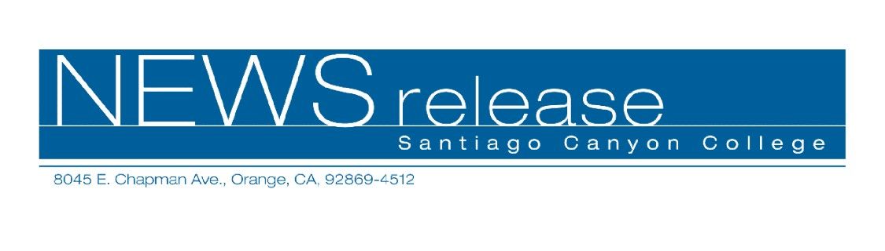
February 17, 2010
For immediate release
Contact: John Weispfenning
714-628-5030
Weispfenning_John@sccollege.edu
Santiago Canyon College Offers Green-Sustainable
Building Certificate Program

Orange—As professionals prepare themselves to meet the requirements of California’s green building code that goes into effect next year for all new construction statewide, Santiago Canyon College (SCC) has launched a Green-Sustainable Building Code certificate program.
The program will provide the training needed by designers, architects, building inspectors, project managers, city inspectors, building energy modelers/consultants, and contractors, as well as the general public interested in sustainable building design.
“Our Green Building Program will focus on the new California regulations, specifically California Title 24 Energy Code, the CALGreen building code, and other green building programs, including Build It Green and LEED,” said David Khorram, P.E., C.B.O., the chief building official with the City of Orange and the International Code Council Orange Empire Chapter(ICCOEC) president. Khorram is the program’s coordinator at SCC.
The new CALGreen code sets targets for energy efficiency, water consumption, dual plumbing systems for potable and irrigation water, diversion of construction waste from landfills and use of environmentally sensitive materials in construction and design, including eco-friendly flooring, carpeting, paint, coatings, thermal insulation and acoustical wall and ceiling panels. It is the first-in-the-nation mandatory green building standards code. Voluntary for the time being, it will become mandatory on January 1, 2011. According to the California Air Resources Board, the mandatory provisions will reduce greenhouse gas emissions by 3,000,000 metric tons by 2020.
To complete the college’s new certificate program, students are required to complete 16 hours of coursework. There are two classes slated for spring semester. The first class—Building Code Administration and Code Enforcement—gets underway on Monday, February 22 and runs for eight
Mondays from 6:00 p.m. to 10:15 p.m. The second class—Sustainable Living and Green Building
- m o r e -
2-2-2
Projects—runs for four Mondays beginning April 26 from 6:00 p.m. to 10:15 p.m. For more information, contact (714) 628-4883 or visit www.sccollege.edu.
“SCC’s new program will provide people from many professions with needed work skills,” said Khorram. “Not only will those with jobs be better prepared to adhere to the new state requirements, but those seeking employment will be better poised to find a good job. Many future jobs in California, nationwide, and even worldwide will be based on efficiency and reducing our dependence on fossil fuels to preserve and protect the planet and the environment we live in.”
Santiago Canyon College is a public community college of Rancho Santiago Community College District, serving the residents of Anaheim Hills, Orange, Tustin and Villa Park. The college provides education for academic transfer and careers, courses for personal and professional development, and customized training for business and industry.
# # #

