

NEWS
May 23, 2007

Contact: Dalilah Davaloz

FOR IMMEDIATE RELEASE

Public Information Officer
(714) 564-6475, Mobile (714) 623-8654

SAC Inducts Distinguished Alumni to the 2007 Hall of Fame

Four alumni from Santa Ana College will be inducted into the Alumni Achievement Hall of Fame at a ceremony scheduled for Friday, June 1, in Santa Ana College’s Phillips Hall at 3:30 p.m. The ceremony will be followed by a reception in adjacent patio area.
The inductees for 2007 are Kenneth C. Ulrich, Dennis A. Farell, Rolf Engen and Dr. Jeffrey L. Armstrong.
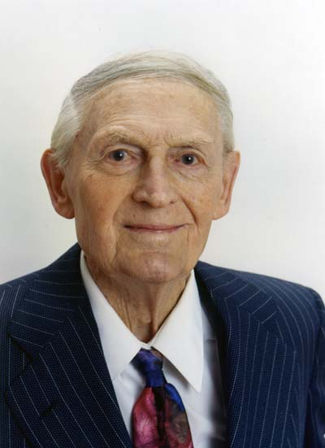
Kenneth Ulrich is the co-owner and founder of Means & Ulrich, a construction firm headquartered in the city of Santa Ana. He attended Tustin High School and served in the United States Navy. Ulrich graduated from Santa Ana College (SAC) in 1934 with an associate’s degree in engineering. He has been responsible for more than $50 million in public works construction projects. Two of his notable projects, include Hoag Hospital in Newport Beach and the hangers at the former Tustin Marine base. Ulrich also developed a construction apprenticeship program and was recognized by the state of California for his leadership in this project.
“I credit the professors at Santa Ana College for my education and success,” said Ulrich. “And, I have always made sure my daughters attended SAC before transferring to a university.”
Dennis A. Farrell, a sports journalist, is a 1971 alumnus from SAC and also holds a bachelor’s degree from San Diego State University. “While at SAC, I served as sports editor and editor in chief of the student newspaper, el Don,” said Farrell. “The small class size and personalized instruction prepared me to succeed at the university level and throughout my career.”
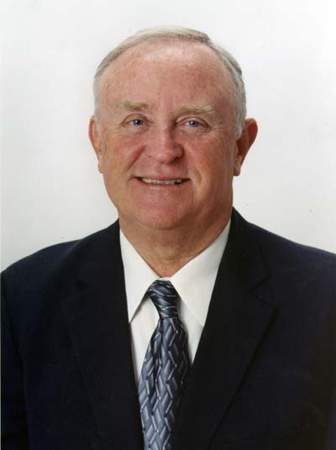
He currently serves as commissioner of the Big West Conference, which is the governing body for eight California member schools that compete in 17 sports. Farrell has also work at the Los Angeles Times, Daily Californian and Saddleback Valley News. In 1995, College Sports Magazine named him one of five most influential people in community college athletics.
“SAC provided a vital educational opportunity for me, one that was affordable. My two brothers also attended SAC, so the decision to attend was a no-brainer,” continued Farrell.

- more -

SAC Hall of Fame 2007 Page 2

Rolf Engen is a world-class athlete and entrepreneur. Engen played men’s basketball for the college, and The Orange County Register referred to him as one of the top basketball players in SAC history. He graduated from SAC in 1950 and transferred to the University of California, Los Angeles (UCLA) on a sports scholarship. Unfortunately, a car accident cut his basketball career short, but he was able to focus his athletic ability into volleyball.
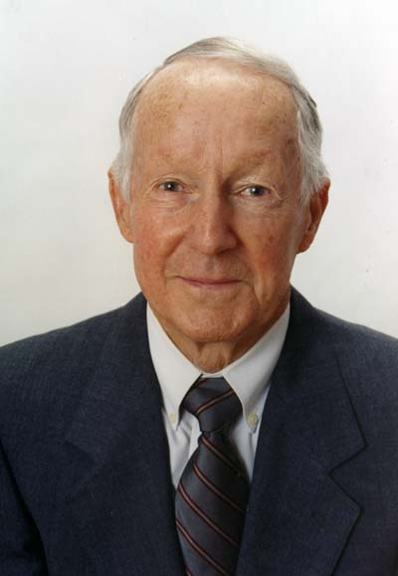
At UCLA, he proved equally talented in volleyball and led the team in earning a national championship. After college, Engen went on to achieve six national titles with the YMCA Team and earned the title of outstanding player on the All-American Team.
He is also the founder and owner of Rolf Engen, Inc., which operates wine retail stores located in the cities of Irvine, Orange, Tustin and Newport Beach. Engan has also taught at Santa Ana High School and coached athletics at Laguna Beach High School.
“It’s simple. Without SAC, I would not have attended college and been able to experience the exciting and fulfilling life I have led,” said Engen.
Dr. Jeffrey L. Armstrong, from SAC’s class of 1988, is currently the president of the Society of Environmental Toxicology and Chemistry, Orange County chapter. He received his bachelor’s and master’s degree in biology from California State University, Long Beach and a doctorate in biological oceanography from City University, Los Angeles where he graduated summa cum laude.
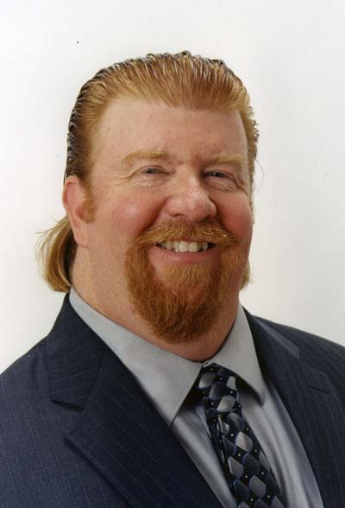
Armstrong has experienced a diverse career, including serving as a police officer and a college professor. He gives back to the community through his involvement in the Da Vinci Mentor Program, motivating high school students who are interested in pursuing a career in the sciences. As a professor of marine biology at California State University, Long Beach, he has published research articles in scientific publications, contributed to scientific textbooks, presented presentations at numerous conferences throughout the country, and briefed Congress on issues relating to emerging contaminates in United States waters.
“SAC provided the ideal experience in preparation for undergraduate and graduate level studies,” said Armstrong. “The solid foundation I obtained at SAC, started me on the path to success!”
- more -

SAC Hall of Fame 2007 Page 3

The Santa Ana College Foundation solicits nominations for the Hall of Fame each March with a selection process occurring in April. The selection committee is composed of a cross segment of college faculty, staff, students and foundation board members. The winners are officially presented and formally inducted at the college’s annual commencement ceremony.
The Santa Ana College Foundation fosters support for the college, its students and faculty. It is a non-profit corporation with a volunteer board of directors. Their commitment is to generate unrestricted resources needed to expand programs, improve facilities and support students. For more information, contact Christina Romero, foundation director at (714) 564-6091.

About Santa Ana College
Santa Ana College is a public community college that serves nearly 50,000 credit and non-credit students annually. SAC provides education for academic transfer and careers, courses for personal and professional development, customized training for business and industry, and programs to train nurses, firefighters and law enforcement personnel.

# # #

