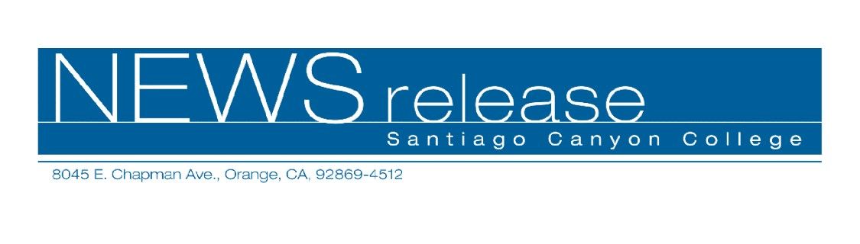
FOR RELEASE: IMMEDIATELY
CONTACT: ANNMARIE LIBRESCU
714-628-4745
librescu_annmarie@sccollege.edu
Handmade Greeting Cards Make Any Occasion Special
February 14— Learn how to make beautiful, one-of-a-kind greeting cards for Mother’s Day, weddings or any special occasion. “Handmade Greeting Cards” is a two-session class held by Santiago Canyon College’s Community Services program that begins on Saturday, February 25.
During the first class (February 25) you’ll learn the art of papermaking. Create unique deckle-edged, lace-embossed and canvas papers. In the second class (March 4) you’ll learn a no-fail method of decorative painting that teaches you how to blend and shade colors. It’s fun and easy to learn.
“Handmade Greeting Cards” is taught by a team of talented instructors, Patrice Goldberg and Patty Lester. Patrice Goldberg is a paper and collage artist. Patty Lester is a certified one-stroke instructor and an accomplished decorative painter.
Registration is $59 plus a $39 materials fee (for paint, brushes and papermaking supplies) payable at the first class meeting. “Handmade Greeting Cards” will be held on two Saturdays, February 25 and March 4 from 1:00-3:30 p.m. at Santiago Canyon College, room D-110. The college is located at 8045 E. Chapman Avenue in Orange.
To register, obtain more information or get directions, call (714) 628-4960 or visit the web site at www.sccollege.edu/cs.
Santiago Canyon College is a public community college of Rancho Santiago Community College District serving the residents of Anaheim Hills, Irvine, Orange, Tustin and Villa Park. The college provides education for academic transfer and careers, courses for personal and professional development, and customized training for business and industry.

###

