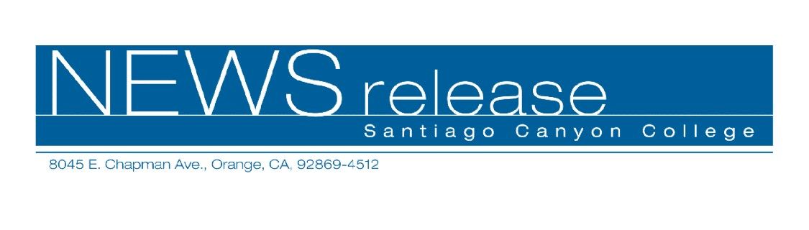
May 24, 2007
FOR IMMEDIATE RELEASE
Contact: AnnMarie Librescu (714) 628-4745
Public Information Officer
Librescu_AnnMarie@sccollege.edu

Lorna Hertogh Receives Santiago Canyon College’s

Non-Credit Faculty Excellence Award

Orange, CA—Lorna Hertogh of Fullerton has been selected as Santiago Canyon College’s (SCC) 2007 Non-Credit Faculty Excellence Award winner for those instructors who teach classes that are not for college credit. Hertogh was awarded a plaque to recognize her outstanding efforts in continuing education at SCC.
Hertogh has been teaching non-credit continuing education classes at SCC for the past 10 years. Prior to working at the college, Hertogh was a program director at the RIO Senior Day Care facility in Orange. She holds a bachelor’s degree in human resources from California State University, Fullerton.
“My teaching philosophy is to learn while I teach,” said Hertogh. “I find that older students are rich with interesting life stories, lessons and experiences.”
Hertogh would like to acknowledge her peers who were also nominated. “I am one of many instructors who give of their time and efforts to help improve the lives of our older adult population,” said Hertogh.
Nomination criteria for the Faculty Excellence Award include service to the college, commitment to student success, curriculum development and academic leadership. Nominations are by students and faculty, and final selection is determined by faculty vote.
SCC is a public community college of the Rancho Santiago Community Colleges District, serving the residents of Anaheim Hills, Irvine, Orange, Tustin and Villa Park. The college provides education for academic transfer and careers, courses for personal and professional development, and customized training for business and industry.

# # #

