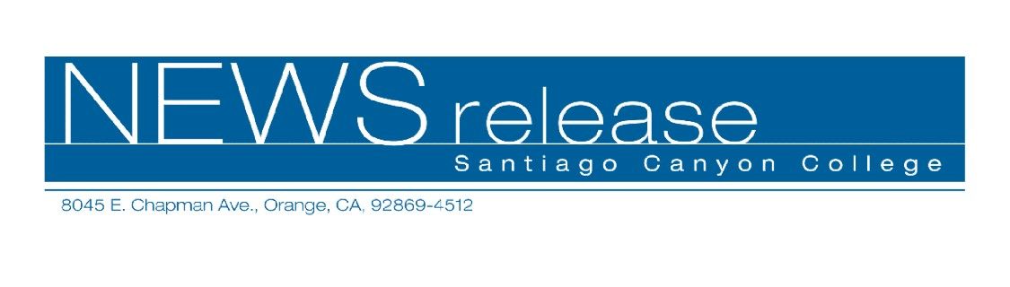
FOR RELEASE: IMMEDIATELY
CONTACT: ANNMARIE LIBRESCU
714-628-4745
librescu_annmarie@sccollege.edu

SANTIAGO CANYON COLLEGE PRESENTS WORLD PREMIERE OF CONCERT

November 8 – Santiago Canyon College (SCC) presents the 2006 Holiday Festival Concert featuring the world premiere of renowned Southern California composer Robert W. Parker’s “Te Deum.” The performance will include choral music from the Southern California Chamber Singers accompanied by California Brass and conducted by Dr. Larry K. Ball. The concert takes place on Saturday, December 9, 7:30 p.m. at First Baptist Church in Santa Ana.
“The Parker premiere will be a major Southland musical event. Throughout time, most major composers have set the ‘Te Deum’ text to music. Now SCC’s Chamber Singers have the privilege of presenting what will become an important musical contribution to the repertoire of significant American choral literature.”
The concert will feature traditional holiday favorites, carols and a sing-along for the crowd to engage in. In addition to California Brass, the melodic chords of the harp will accompany several musical selections. The Southern California Chamber Singers, a chorale made up of 39 SCC students, is sure to put on a concert that the whole family will enjoy.
Tickets for this special holiday concert are on sale now for $15 per person. Tickets are also available for purchase at the door the day of the concert.

-more-
Santiago Canyon College Presents World Premiere of Concert Page 2 of 2

First Baptist Church is located at 1010 W. 17th Street in Santa Ana. For tickets or additional information please call (714) 628-4828.
Santiago Canyon College is a public community college of Rancho Santiago Community College District, which serves the residents of Anaheim Hills, Irvine, Orange, Tustin and Villa Park. The college provides education for academic transfer and careers, courses for personal and professional development and customized training for business and industry.

# # #

