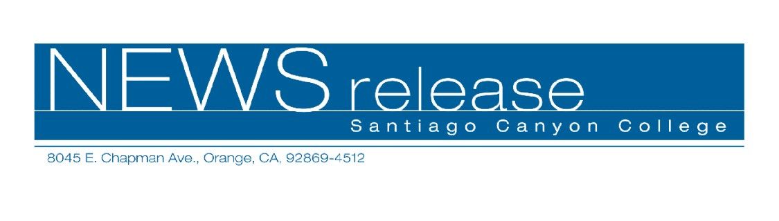
FOR RELEASE: IMMEDIATELY
CONTACT: ANNMARIE DEASY
714-628-4745
deasy_annmarie@sccollege.edu

How to Be Your Own Private Investigator

June 9—Are you interested in becoming your own private investigator? In California, no license is needed as long as you are investigating for yourself. In “How to Become Your Own Private Investigator,” Jim Harriger, a licensed private investigator and criminal justice instructor, shows you how to get started.
“The class is for people who want to save money by doing their own investigation,” explained Harriger. “The biggest secret is knowing where the information is and that’s what I go over in the class.”
People who might be interested in taking the class include those wanting to collect on financial judgments owed to them, landlords wanting to do their own background checks, and people going through divorces who want to investigate a spouse. According to Harriger, private investigators charge an average of $55 an hour (plus mileage), for investigations.
“How to Become Your Own Private Investigator” will be held Wednesday, June 22 from 6:30 p.m. to 9:30 p.m. at Santiago Canyon College, Room A-104, 8045 E. Chapman Ave., in Orange. The fee for the workshop is $39 and there is an optional workbook that may be purchased for $25 in class.
Harriger is a retired Los Angeles police officer with over 37 years of investigative experience. He has taught “How to Become Your Own Private Investigator” for over 13 years and currently works as an insurance fraud investigator.
For more information on this or other Community Services classes, call (714) 628-4960 or visit www.sccollege.edu/cs.
Santiago Canyon College is a public community college of Rancho Santiago Community College District serving the residents of Anaheim Hills, Irvine, Orange, Tustin and Villa Park. The college provides education for academic transfer and careers, courses for personal and professional development, and customized training for business and industry.

###

