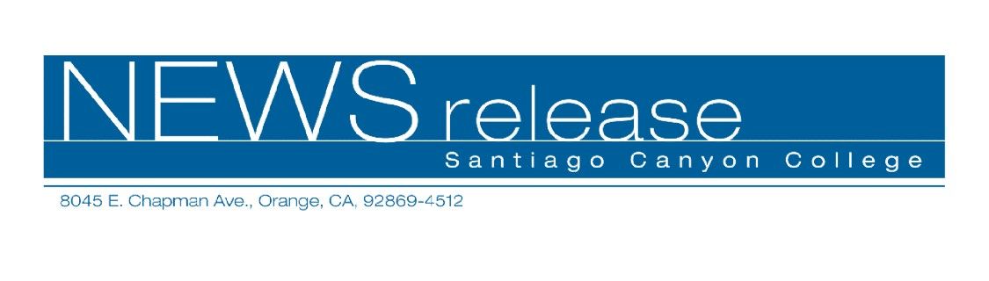
FOR RELEASE: IMMEDIATELY
CONTACT: ANNMARIE DEASY
714-628-4745
deasy_annmarie@sccollege.edu

CONTACT: Delite Young
909-481-7200
dyoung@ca-nv-awwa.org

Joint Instrumentation Conference for Water Industry Professionals to be held at Santiago Canyon College

July 30— Santiago Canyon College and the California/Nevada Section of the American Water Works Association (CA-NV-AWWA) will co-sponsor the annual Joint Instrumentation Conference on Wednesday, August 11, 2004 at the college campus. The JIC workshop features state-of-the-art training tailored to professionals in the water/wastewater industry and will provide contact hours required for license renewal. Water/wastewater operators, managers, engineers, technicians, as well as field and laboratory personnel will find the workshop beneficial.
Hour-long classes taught by highly qualified experts will be presented throughout the one-day workshop. Topics include pump control, SCADA hardware/software, water sampling/disinfection, backflow prevention, traffic control, water conservation, water/audits leak detection, energy conservation, security/emergency practices, and more.
Classes, parking, exhibits, morning and afternoon refreshment breaks and lunch are included in the advance registration price of $75 ($100 at the door). The conference is expected to draw up to 650 participants.

--more--
JIC Workshop at Santiago Canyon College 2 of 2

Santiago Canyon College provides the only comprehensive water utility science program (leading to an associate degree or certificate) in Orange County. The program assists students in obtaining basic and advanced water industry licensure and provides contact hours for those already working in the field.
The college is located at 8045 E. Chapman Avenue in Orange. For more information about the JIC workshop, please call CA-NV-AWWA at (909) 481-7200 or visit the website at www.ca-nv-awwa.org. For information on Santiago Canyon College’s Water Utility Science program, please call (714) 628-4883 or visit the web site at http://www.sccollege.org/watersci/.
Santiago Canyon College and Santa Ana College are public community colleges of Rancho Santiago Community College District which serves the residents of Anaheim Hills, Garden Grove, Irvine, Orange, Santa Ana, Tustin and Villa Park. Both colleges provide education for academic transfer and careers, courses for personal and professional development, and customized training for business and industry.
The California-Nevada Section, AWWA is the largest section in the American Water Works Association, with over 8,000 members. The section has over fifty standing committees and hosts both a spring and fall conference annually. The CA-NV-AWWA Water College has scheduled more than fifty workshops this year, in addition to hosting its two annual educational symposia. The CA-NV section has been a leader in developing water industry guidelines, certification programs, standards, procedures, training and newsletters. For information on
CA-NV section services and activities, visit the website at www.ca-nv-awwa.org, call (909) 481-7200 or fax to (909) 481-4688.
-30-

