
FOR RELEASE: IMMEDIATELY
CONTACT: ANNMARIE LIBRESCU
714-628-4745
librescu_annmarie@sccollege.edu
John Hernandez Receives National Mentoring Award
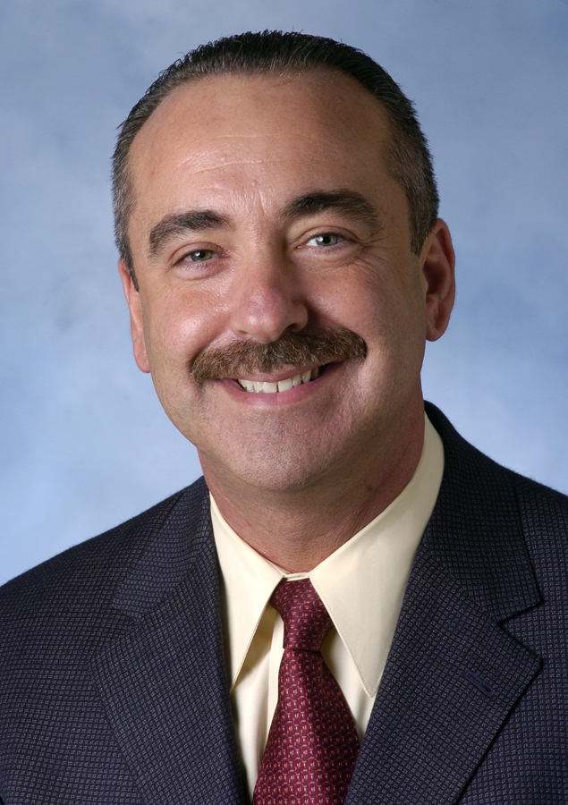
April 19—Santiago Canyon College Student Services Vice President John Hernandez received the 2006 William L. Thomas Mentoring Award from the University of Maryland’s College Student Personnel Graduate program. Hernandez, who earned his Ph.D. from the University of Maryland, College Park, was nominated by current students and alumni for his many years of mentoring graduate students and new professionals.
Dr. Hernandez has encouraged many young people to pursue their education and enter careers in student services, which includes counseling, financial aid, tutoring and other support programs that colleges offer to help students succeed. He has received special recognition for his work with first-generation Latino students. Hernandez sees mentoring as a professional responsibility that he pursues with passion. It’s not uncommon for him to keep in touch via e-mail with students from throughout the U.S. for five, ten or more years as they graduate from college and begin their careers. He maintains list serves that alert student services professionals to jobs and other news in the field.
“The Santiago Canyon College community is very proud that Dr. Hernandez has been recognized with this honor,” said college President Juan Vázquez. “He is an outstanding member of our executive staff, and our students benefit from his leadership and dedication.”
Dr. Hernandez is so well-known and respected among his peers that the American College Personnel Association’s (ACPA) Latin@ Network (a standing committee for multicultural affairs)
named an award after him. The John Hernandez Leadership Award is given annually to an outstanding student affairs practitioner who has demonstrated leadership, citizenship and active participation within the Latin@ Network.
—more—
Hernandez Receives National Mentoring Award Page 2 of 2

In addition to his professional association with ACPA, Dr. Hernandez is a sought-after conference speaker and author of several articles that have been published in professional journals.
Prior to his vice presidency at Santiago Canyon College, Dr. Hernandez held leadership positions at California State Polytechnic University, Pomona and Santa Ana College. He holds a bachelor’s degree in sociology from California State University, Fullerton, a master’s degree in counseling from California State University, Long Beach, and a Ph.D. in college student personnel administration from the University of Maryland, College Park. Dr. Hernandez resides in Anaheim.
Santiago Canyon College was recently recognized by The Hispanic Outlook in Higher Education magazine as being among the top 50 community and junior colleges in the U.S. by Hispanic enrollment. A public community college of Rancho Santiago Community College District, the college serves the residents of Anaheim Hills, Irvine, Orange, Tustin and Villa Park. Santiago Canyon College provides education for academic transfer and careers, courses for personal and professional development, and customized training for business and industry.

###

