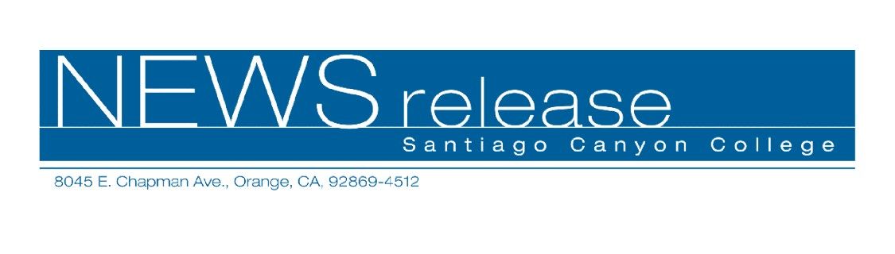
FOR RELEASE: IMMEDIATELY
CONTACT: ANNMARIE DEASY
714-628-4745
deasy_annmarie@sccollege.edu
Santiago Canyon College Breaks Ground on New Library

January 13—Santiago Canyon College breaks ground on the nearly 40,000 square foot Library/Learning Resource Center on Tuesday, January 25, 12:30 p.m. at Strenger Plaza. The new building, largely funded by state revenue, is part of an aggressive construction plan designed to bring college facilities in line with enrollment growth. In a recent analysis by Community College Week, Santiago Canyon College ranked second on a list of the fifty fastest-growing public two-year colleges in the U.S.*
The Library/Learning Resource Center allows for much-needed expansion of media materials and shelf space for 100,000 books. Instructional resources such as the tutoring center and faculty technology training center will be housed in the facility, and space has been allocated for student art displays. Building completion and occupancy are expected in 2006.
“The college’s new Library and Learning Resource Center will have a significant impact on our students’ educational experience,” said Juan Vázquez, Santiago Canyon College president. “It will provide a place to study and learn as well as access to a wealth of technology such as media viewing stations, advanced technology classrooms and a wireless network.”
The groundbreaking celebration includes refreshments, student entertainment, displays and virtual tours of the new building. Free parking is available in Lot 4. The college is located at 8045 E. Chapman Avenue in Orange. For a map or directions, please visit the web site at www.sccollege.edu. For additional information about the event, please call (714) 628-4745.
--more--

Santiago Canyon College Breaks Ground on New Library Page 2 of 2

Santiago Canyon College and Santa Ana College are public community colleges of Rancho Santiago Community College District which serves the residents of Anaheim Hills, Garden Grove, Irvine, Orange, Santa Ana, Tustin and Villa Park. Both colleges provide education for academic transfer and careers, courses for personal and professional development, and customized training for business and industry.

*Among institutions with 10,000 or more students, ranked by percent of growth in headcount from fall 2002 to fall 2003.
Source: Community College Week Analysis of U.S. Department of Education Data. Community College Week 6 Dec. 2004: 6-9.

-30-

