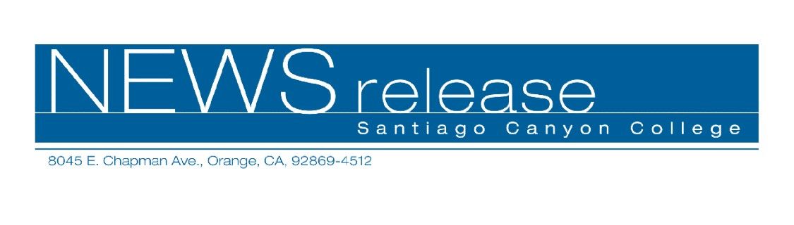
FOR RELEASE: IMMEDIATELY
CONTACT: ANNMARIE LIBRESCU
714-628-4745
librescu_annmarie@sccollege.edu
Santiago Canyon College Students to attend
Harvard Model United Nations Conference

February 4—Nine students will represent Santiago Canyon College’s Model United Nations team at the Harvard Model United Nations 2008 Conference from Thursday, Feb. 14 to Sunday, Feb. 17 in Boston, MA.
The students will join more than 2,600 delegates from around the world, accompanied by their faculty adviser, Narges Rabii, assistant professor of history and political science at Santiago Canyon College.
“Each school is assigned a country other than their own; our students will represent Equatorial Guinea, which joined the U.N. in 1968,” said Rabii.
There are 192 member states in the United Nations, which was formed in 1946; all have equal voting rights on every issue.
The Harvard Model United Nations was founded a decade later; this is the 54th and oldest simulation of its kind, where students from around the world can interact and learn about international relations and experience first-hand the challenges diplomats face.
“Our students will serve on seven committees; each committee is assigned two topics, so we must present the position of Equatorial Guinea on fourteen topics,” Rabii said. The scoring system is designed to provide feedback for improvement, and scores are kept by committee chairs. “Judges will subtract points if students go off-topic and for other infractions,” Rabii explained.
--more—

Santiago Canyon College Model UN Team to Compete at Harvard 2 of 2

SCC team members are: David Wylie, Nichol Forbes and Tuan Ngyuen of Orange; Phil Nemeth of Whittier; Regina Lozic of Newport Beach; Christina Corbin of Tustin; Eryn Rush of Huntington Beach, Julianna Oranelas of Yorba Linda, and Doug Arseneault, formerly of Columbia, MD.
Students may participate in the Model United Nations program at Santiago Canyon College by enrolling in Political Science 121, 122, and 123. “There are many benefits,” Rabii said, “including opportunities to travel. And students can earn up to seven extracurricular units, which is viewed very favorably by admissions committees when students are applying to other colleges and universities. But membership also carries significant responsibilities to the team, which does about 80 hours of research for every conference they attend. It’s a lot of fun, but it’s also a lot of work.”
For additional information about the program or the upcoming conference, please contact Narges Rabii at (714) 628-4940.
Santiago Canyon College is a public community college of Rancho Santiago Community College District, serving the residents of Anaheim Hills, Irvine, Orange, Tustin and Villa Park. The college provides education for academic transfer and careers, courses for personal and professional development, and customized training for business and industry.

###

