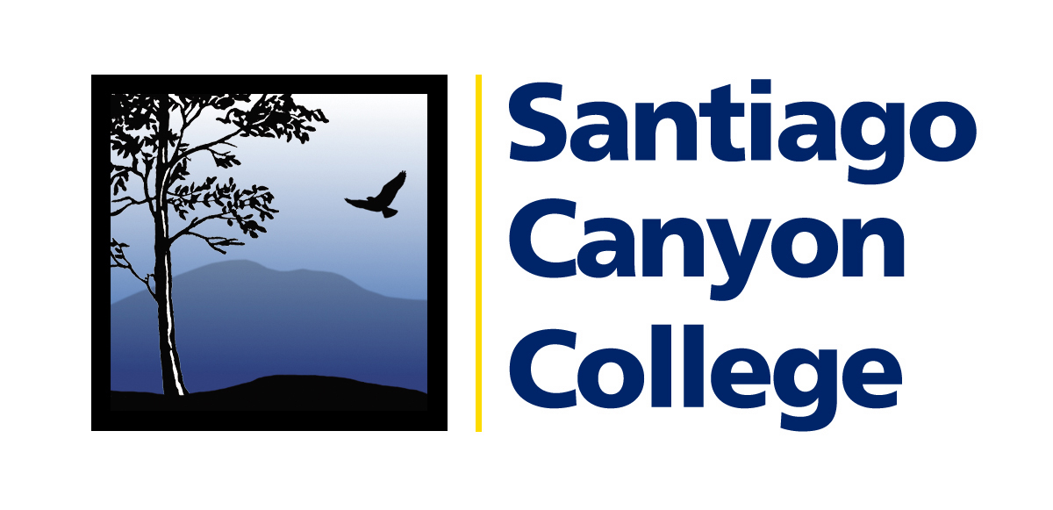

CALENDAR LISTING

Contact: AnnMarie Librescu
Phone: (714) 628-4745
E-mail: Librescu_annmarie@sccollege.edu

Local Author Martin Dugard to speak at Santiago Canyon College

WHAT: New York Times best-selling author and Rancho Santa Margarita resident Martin Dugard will speak about his work at Santiago Canyon College in Orange on Tuesday, May 13.
Dugard is best-known for his writing on cycling and endurance sports, including
Chasing Lance: The 2005 Tour de France and Lance Armstrong’s Ride of a Lifetime.

Dugard has written about famous explorers and adventurers, including Columbus, Captain
Cook, Stanley and Livingston. An adventurer himself, Dugard has completed the two-week Raid Gauloises adventure race, sailed on a tall ship across the Mediterranean, and spent time in an African prison while doing research for one of his books. He is also the co-holder of the around-the-world speed record, flying from New York to New York in 31 hours and 28 minutes while aboard an Air France Concorde in 1996.

During the filming of the television show “Survivor,” Dugard lived for six weeks on the Malaysian island of Palau Tiga. This became the subject for his best-selling book Survivor: The Ultimate Game, co-written with series producer Mark Burnett.

Dugard’s latest book, The Training Ground, focuses on the Mexican War of 1846-48.
Books will be available for purchase and signing at the event.

WHERE: Santiago Canyon College, Room D-101
8045 E. Chapman Ave., Orange

WHEN: Tuesday, May 13, 2-3:30 p.m.

PRICE: Free

About Santiago Canyon College:
Santiago Canyon College serves the residents of Anaheim Hills, Orange and Villa Park, and is a public community college of Rancho Santiago Community College District. The college provides education for academic transfer and careers, courses for personal and professional development, and customized training for business and industry.

# # #

