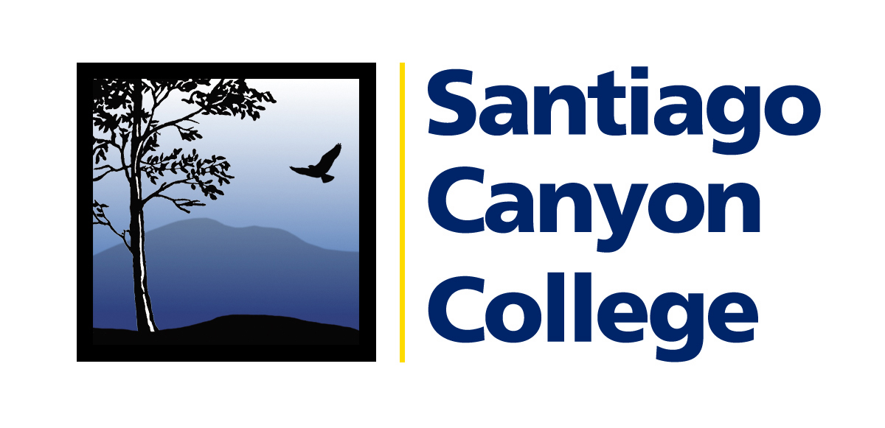

Calendar Listing

Media Contact: AnnMarie Librescu
(714) 628-4745 librescu_annmarie@sccollege.edu

Orange Education Center Hosts Free Citizenship Application Workshop

WHAT: On Saturday, May 19, Santiago Canyon College’s Orange Education Center (OEC) will host a free day-long event to help community members complete the N-400 citizenship application. Volunteer training is provided by the National Association of Latino Elected and Appointed Officials (NALEO) as part of the Ya Es Hora…¡Ciudadanía! campaign.

The event will also include free legal assistance (on a limited basis) and passport photography. Participants should bring their green card, social security card, California state identification card, or driver’s license.

WHEN: Saturday, May 19, 2007
9:00 a.m. to 5:00 p.m.
No appointment or reservation is necessary.

WHERE: Orange Education Center, 1465 N. Batavia Street, Orange 92867

WHY: The cost for filing the citizenship application may increase this year from $400.

PRICE: FREE!

CONTACT: Tom Donahoe, citizenship coordinator, (714) 628-5928.

About the Orange Education Center:
The dedicated faculty and staff of the Orange Education Center provide free classes and services to 10,000 people each year. Non-credit classes offered include computer instruction, health and safety, English as a Second Language, adult basic education, parenting skills, high school and GED programs, and more.

Free citizenship workshops are held every month at:

Orange Education Center, 1465 N. Batavia, Orange 92867, (714) 628-5900
- First and third Saturdays, 12:00-2:00 p.m., second and fourth Tuesdays of the month, 4:00-6:00 p.m.

Anaheim Hills Center, 101 S. Chaparral Ct., Rm. 214, Anaheim Hills 92808, (714) 637-3071
- Last Thursday of the month, 11:30 a.m.-1:30 p.m.

###

